## UNIT- IV:

**Data Integrity, Digital Signature Schemes & Key Management**

Message Integrity and Message Authentication, Cryptographic Hash Functions, Digital Signature, Key Management.



Ch-11 – Message Integrity and Message Authentication

# l. Message Integrity

The cryptography systems that we have studied so far provide *secrecy* or *confidentiality* but not *integrity*. However there are occasions where we may not even need secrecy but instead must have integrity.

### Message and Message Digest

The electronic equivalent of the document and fingerprint is the message and message digest pair. To preserve the integrity of the message, the message is passed through an algorithm called a **Cryptographic hash function**. The function creates a compressed image of the message that can be used like a fingerprint. Figure 11.1 shows the message, cryptographic hash function, and **message digest**.

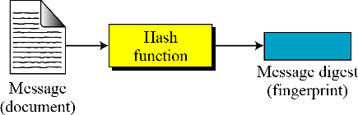

Figure 11.1 Message and Message digest

The message digest needs to be safe from change.

* 1. Checking Integrity

To check the integrity of a message, or document, we run the cryptographic hash function again and compares the new message digest with the previous one. If both are same, we are sure that the original message has not been changed. Figure 11.2 shows the idea.

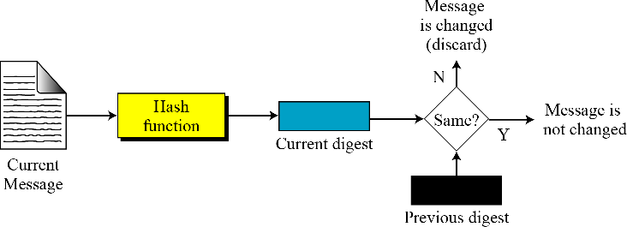

Figure 11.2 Checking integrity

* 1. Cryptographic Hash Function Criteria

A cryptographic hash function must satisfy three criteria:

* + 1. Preimage resistance
    2. Second preimage resistance
    3. Collision resistance.

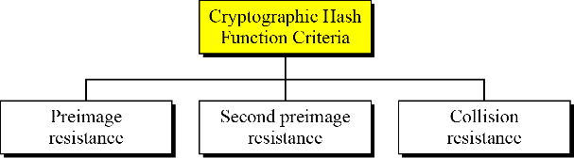

Figure 11.3 Criteria of a cryptographic hash function

#### Preimage Resistance

* This property of the hash function implies given a hashed value it should difficult for an adversary to compute the preimage of the hashed value.
* Given a hash function h and y=h(M) , it must be extremely difficult for Eve to find any message,

M’ such that y=h(M').

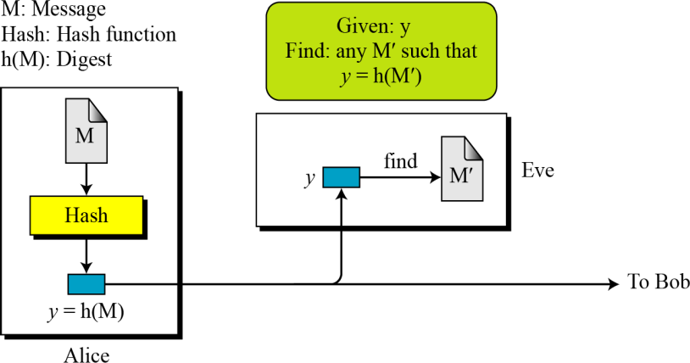



Thus mathematically, a hash function h is said to be preimage resistant, if given the value of y = h(x), for some x it is difficult to compute the value of any x’ such that h(x') = y.

#### Second Preimage Resistance

* + The second criterion, second Preimage resistance, ensure that a message cannot easily be forged.
  + If Alice creates a message and a digest and sends both to Bob, this criterion ensures that Eve cannot easily create another message that hashes to the exact same digest.
  + Eve intercepts a message M and its digest h(M).
  + She creates another message M' ≠ M, but h(M)=h(M').
  + Eve sends the M' and h(M') to Bob. Eve has forged the message.

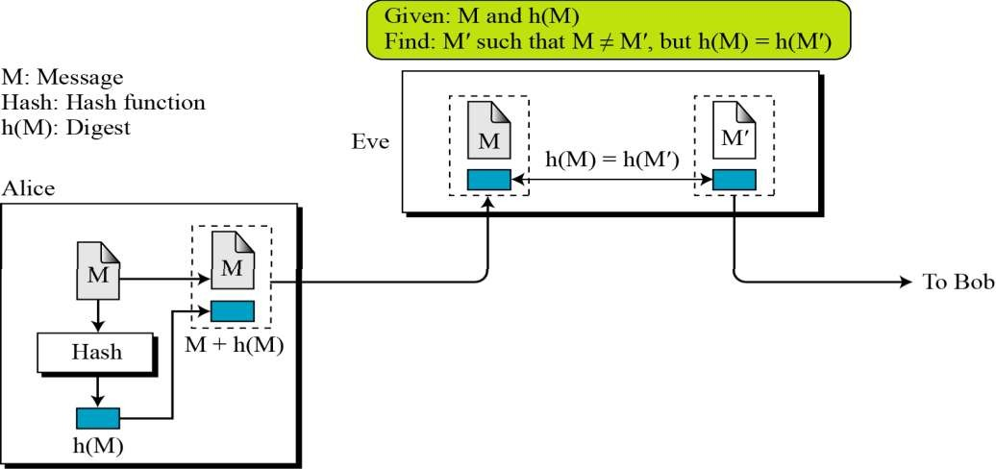

#### Collision Resistance

* + The third criterion, collision resistance, ensures that Eve cannot find two messages that hash to the same digest.
  + Here the adversary can create two messages and hashed to the same digest.
  + 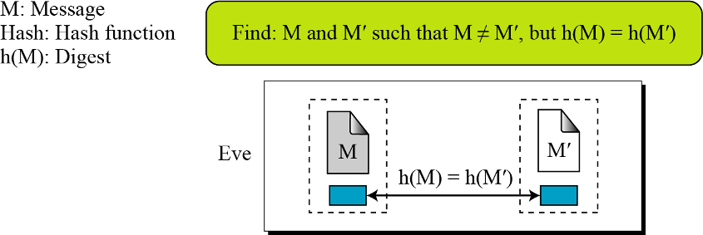For the moment, suppose two different wills can be created, that hash to the same digest.

# Random Oracle Model

The **Random oracle model,** which was introduced in 1993 by Bellare and Rogaway, is an ideal mathematical model for a hash function. A function based on this model behaves as follows:

* 1. When a new message of any length is given, the oracle creates and gives a fixed length message digest that is random string of 0s and 1s. The oracle records the message and the message digest.
  2. When a message is given for which a digest exists, the oracle simply gives the digest in the record.
  3. The digest for a new message needs to be chosen independently from all previous digest. This implies that the oracle cannot use a formula or an algorithm to calculate the digest.

### Pigeonhole principle

* + - The first thing we need to be familiar with no understanding the analysis of the Random Oracle Model is the **pigeonhole principle**: if n pigeonholes are occupied by n+1 pigeons, then at least one pigeonhole is occupied by two pigeons.
    - The generalized versions of the pigeonhole principle is that n pigeonholes are occupied by kn+1 pigeons, then at least one pigeonhole is occupied by k+1 pigeons.
    - Because the whole idea of hashing dictates that the digest should be shorter than the message, according to the pigeonhole principle there can be collisions.
    - In other words, there are some digests that corresponds to more than one message; the relationship between the possible messages and possible digests is many-to-one.

### Birthday Problems

* + - The second thing we need to know before analyzing the Random Oracle Model is the famous

#### birthday problems.

* + - Four different birthday problems are usually encountered in the probability courses.
    - 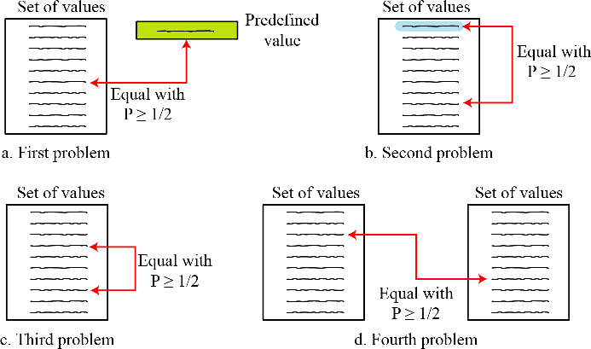The third problem, sometimes referred to as birthday paradox, is the most common one in the literature.

Figure 11.4 Four birthday problems

#### Description of problems

* + - **Probleml:** what is the minimum number, k, of students in a classroom such that it is likely that at least one student has a predefined birthday? This problem can be generalized as follows. We have a uniformly distributed random variable with N possible values (between 0 and N-1).What is the minimum number of instances k, such that it is likely that at least one instance is equal to a predefined value.
    - **Problem 2:** what is the minimum number, k, of students in a classroom such that it is likely that at least one student has the same birthday as the student selected by the professor? This problem can be generalized as follows. We have a uniformly distributed random variable with N possible values (between 0 and N-1). What is the minimum number of instances, k such that it is likely that at least one instance is equal to the select one?
    - **Problem 3:** what is the minimum number, k, of students in a classroom such that it is likely that at least two students have the same birthday? The problems can be generalized as follows. We have a uniformly distributed random variable with N possible values (between 0 and N-1). What is the minimum number of instances, k, such that it is likely that at least two instances are equal?
    - **Problem 4:** we have two classes, each with k students. What is the minimum value of k such that it is likely that at least one student from the first classroom has the same birthday as a student from the second classroom? This problem can be generalized as follows. We have a uniformly distributed random variable with N possible values (between 0 and N-1). We generate two sets of random values each with k instances. What is the minimum number of

k, such that it is likely that at least one instance from the first set is equal to one instance in the second set.

#### Comparison

* + - The value of K in problems 1 or 2 is proportional to N, the value of k in problems 3 or 4 is proportional to N1/2.
    - The first two problems are related to the preimage and second preimage attacks; the third and fourth problems are related to the collision attack.
    - The comparison shows it is much more difficult to launch preimage or second preimage attack than to launch a collision attack.

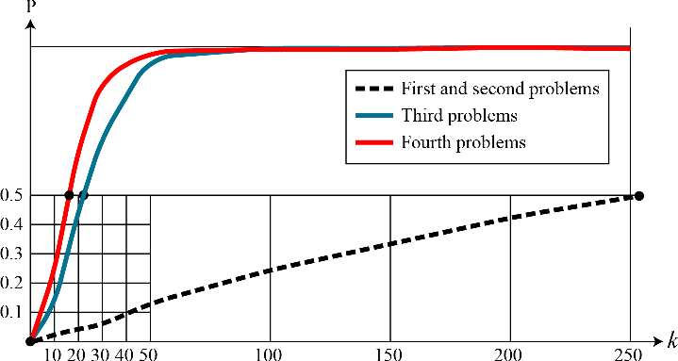

Figure 11.5 Graph of four birthday problems

### Attacks on random oracle model

* + - To better understand the nature of hash functions and the importance of the Random Oracle Model, consider how Eve can attack a hash function created by the oracle.
    - Suppose that the hash function creates a digest of n bits.
    - The digest can be thought of as a random variable uniformly distributed between 0 and N-1 in which N=2n.

#### Preimage attack

* + - 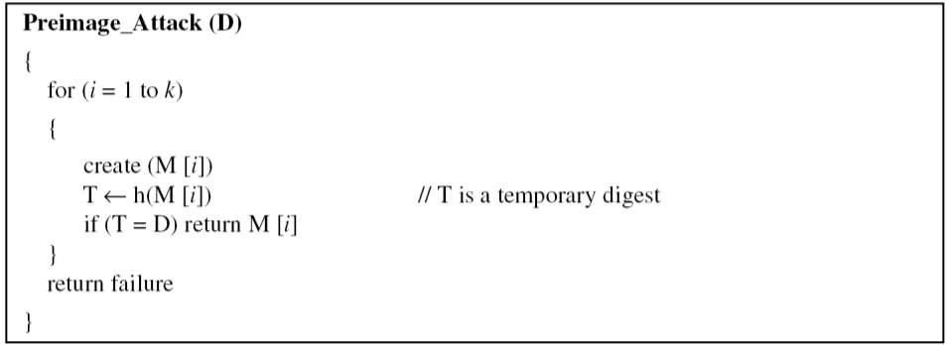Eve has intercepted a digest D=h(M). She wants to find a message M' such that D=h(M').

The difficulty of a preimage attack is proportional to 2n

#### Second Preimage attack

* + - Eve has intercepted a digest D=h(M) and the corresponding message M. She wants to find another message M' so that h(M')=D.
    - 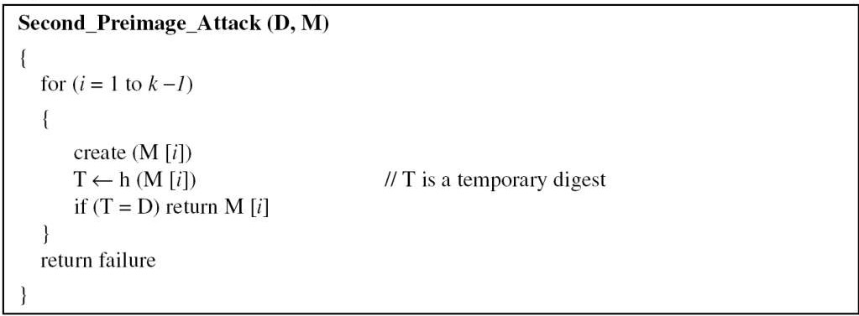Eve can create a list of k-1 messages.

The difficulty of second preimage attack is proportional to 2n.

#### Collision attack

* + - 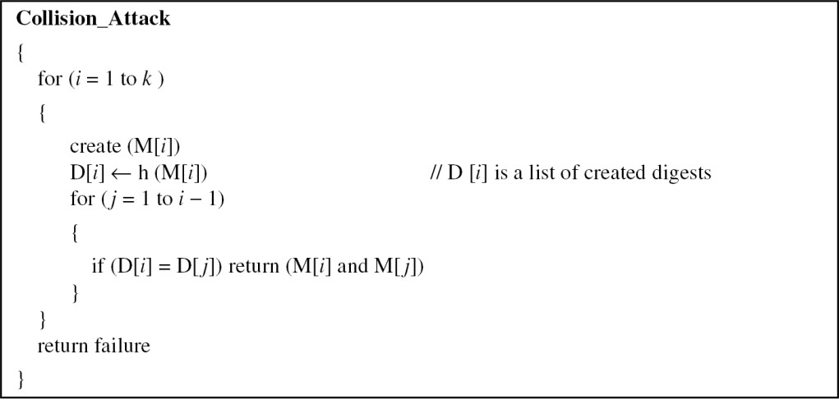Eve needs to find new messages M and M' such that h(M)=h(M').Eve can create a list of k messages

The difficulty of a collision attack is proportional to 2n/2.

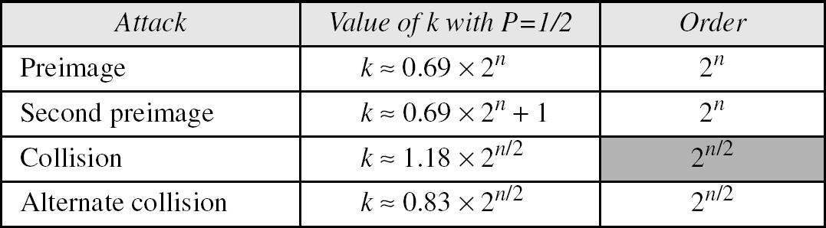

Table 11.1 Levels of difficulties for each type of attack.

# Message Authentication

* A message digest guarantees the integrity of the message. It guarantees that the message has not been changed.
* A message digest, cannot authenticate the sender of the message.
* When Alice sends a message to Bob, Bob needs to know if the message is coming from Alice.
* To provide a message authentication, Alice needs to provide proof that it is Alice sending message and not an imposter.
* The digest created by a cryptographic hash function is normally called a modification Detection code (MDC).
* The code can detect any modification in the message.

What we need for message authentication is a message authentication code (MAC).

### Modification Detection Code

* + - A modification detection code (MDC) is a message digest that can prove the integrity of the message: that message has not been changed.
    - If Alice needs to send a message to Bob and be sure that the message will not change during transmission, Alice can create a message digest MDC and send both the message and the MDC to Bob.
    - Bob can create a new MDC from the message and compare the received MDC and the new MDC.
    - If they are same, the message has not been changed. Figure 11.6 shows the idea.

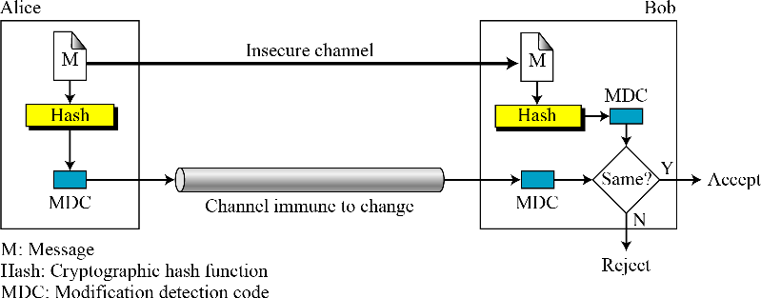

Figure 11.6 Modification detection code (MDC)

### Message Authentication Code (MAC)

To ensure that the integrity of the message and the data origin authentication—that Alice is the originator of the message, not somebody else- we need a change modification detection code (MDC) to message authentication code (MAC). The difference between that a MDC and a MAC is that the second includes a secret between Alice and Bob—for example, a secret key is that Eve does not possess. Figure 11.7 shows the idea.

Alice uses a hash function to create a MAC from the concatenation of the key and the message, h(K | M). She sends a message and the MAC to Bob over the insecure channel. Bob separates the message from MAC. He then makes a new MAC from the concatenation of the message and the secret key. Bob then compares the newly created MAC with the one received. If the two MAC’s match, the message is authentic and has not been modified by adversary.

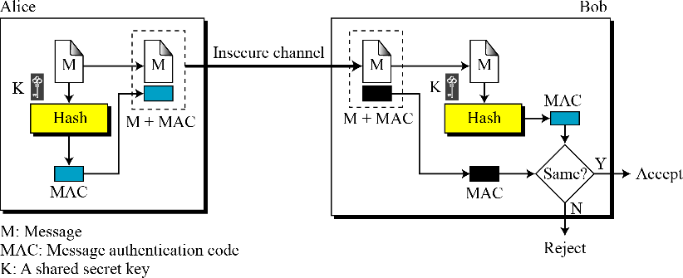

Figure 11.7 Message Authentication Code (MAC)

#### Security of MAC

Suppose Eve has intercepted the message M and the digest h(K|M). How Eve can forge a message without knowing the secret key? There are three possible cases:

1. If the size of the key allows exhaustive search, Eve may prepend all possible keys at the beginning of the message and make a digest of the (K|M) to find the digest equal to the one intercepted. She then knows the key and can successfully replace the message with a forged message of her choosing.
2. The size of the key is normally very large in MAC.
3. Given some pairs of messages and their MAC’s, Eve can manipulate them to come with a new

message and its MAC.

The security of the MAC depends on the security of underlying hash algorithm.

**Nested MAC**

### To prove the security of MAC, nested MAC’s were designed in which hashing is done in two steps: In the first step, the key is concatenated with the message and is hashed to create an immediate digest. In the second step, the key is concatenated with an intermediate digest to create a final digest.

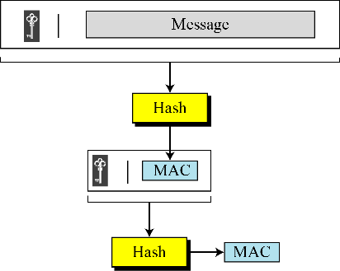

Figure 11.8 Nested MAC

#### HMAC

The implementation of HMAC (Hashed MAC) is more complex than the simplified nested MAC shown in Figure 11.8. There are additional features such as padding. Figure 11.9 shows the details. We go through the steps:

1. The message is divided into N blocks, each of b bits.
2. The secret key is left-padded with 0’s to create a b-bit key.
3. The result of step-2 is exclusive-ored with a constant called ipad (input pad) to create a *b*-bit block. The value of ipad is the *b*/8 repetition of the sequence 00110110 (36 in hexadecimal).
4. The resulting block is prepended to the N-block message. The result is N+1 blocks.
5. The result of step-4 is hashed to create an n-bit digest. We call the digest the intermediate HMAC.
6. The intermediate n-bit HMAC is left padded with 0s to make a *b*-bit block.
7. Steps 2 and 3 are repeated by a different constant opad (output pad). The value of opad is the *b*/8 repetition of the sequence 01011100 (5C in hexadecimal).
8. The result of step 7 is prepended to the block of step 6.
9. The result of step 8 is hashed with the same hashing algorithm to create the final n-bit HMAC.

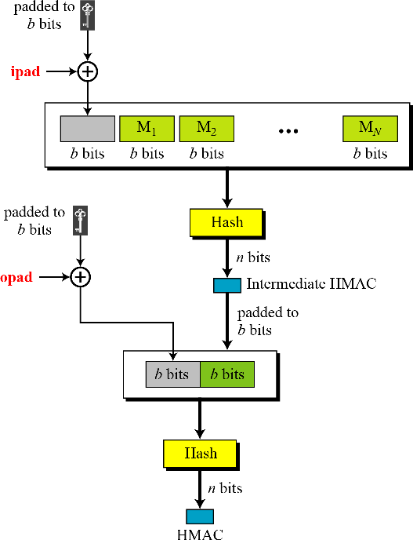

Figure 11.9 Details of HMAC

#### CMAC (Cipher based MAC)

The idea is to create one block of MAC from N blocks of plaintext using a symmetric-key cipher N times. Figure 11.10 shows the idea.

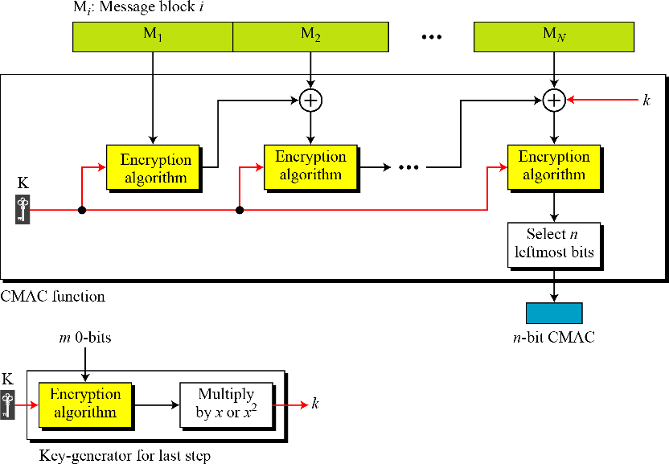

Figure 11.10 CMAC

* + - The message is divided into *N* blocks, each m bits long.
    - The size of the CMAC is n-bits. If the last block is not m-bits, it is padded with a 1- bit followed by enough 0-bits to make it m bits.
    - The first block of the message is encrypted with the symmetric key to create an m-bit block of encrypted data.
    - This block is XORed with the next block and the result is encrypted again to create a new m- bit block.
    - The process continues until the last block of the message is encrypted.
    - The n leftmost bit from the last block is the CMAC.

In addition to the symmetric key, K, CMAC also uses another key, k, which is applied only at the last step. This key is derived from the encryption algorithm with plaintext of m 0-bits using the cipher key, K. The result is then multiplied by x if no padding is applied and multiplied by x2 if padding is applied. The multiplication is in GF(2m) with the irreducible polynomial of degree m selected By the particular protocol used.



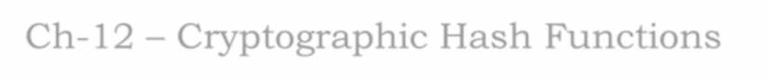

Ch-12 – Cryptographic Hash Functions

As discussed in Chapter 11, a cryptographic hash function takes a message of arbitrary length and

creates a message digest of fixed length. The ultimate goal of this chapter is to discuss the details of the two most promising cryptographic hash algorithms-Sha-512 and Whirlpool.

# l. Iterated Hash Function

All cryptographic hash functions need to create a fixed-size digest out of a variable-size message. Creating such a function is best accomplished using iteration. The fixed size input function is referred to as a *compression function*. It compresses an n-bit string to create an m-bit string where n is normally greater than m. the scheme is referred to as an ***iterated cryptographic hash function***.

**Merkle-Damgard Scheme** The Merkle-Damgard scheme is an iterated hash function that is collision resistant if the compression function is collision resistant. The scheme is shown in figure 12.1.

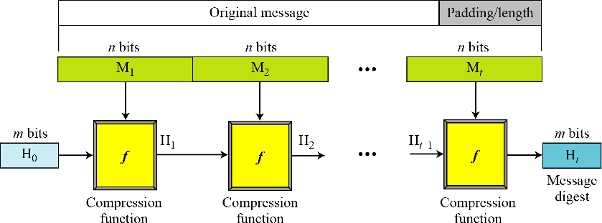

Figure 21.1 Merkle-Damgard scheme The scheme uses the following steps:

1. The message length and padding are appended to the message to create an augmented message that can be evenly divided into blocks of n bits, where n is the size of the block to be processed by the compression function.
2. The message is then considered as t blocks, each of n bits. We call each block M1, M2, …, Mt. We call the digest created at t iterations H1, H2, …, Ht.
3. Before starting the iteration, the digest H0 is set to a fixed value, normally called IV (initial value or initial vector).
4. The compression function at each iteration operates on Hi-1 and Mi to create a new Hi. In other words, we have Hi = f(Hi-1, Mi), where *f* is the compression function.
5. Ht is the cryptographic hash function of the original message, that is h(M).

### 1.1 Two Groups of Compression Functions

The Merkle-Damgard scheme is the basis for many cryptographic hash functions today. Three is a tendency to use two different approaches in designing a hash function. In the first approach, the compression function is made from scratch: it is particularly designed for this purpose. In the second approach, a symmetric-key block cipher serves as a compression function.

#### Hash Functions Made from Scratch

A set of cryptographic hash functions uses compression functions that are made from scratch. These compression functions are specifically designed for the purposes they serve.

**Message digest (MD)** Several hash algorithms were designed by Ron Rivest. These are referred to as MD2, MD4, and MD5, where MD stands for Message Digest. The last version, MD5, is a strengthened version of MD4 that divides the message into blocks of 512 bits and creates a 128- bit digest. It turned out that a message digest of size 128 bits is too small to resist collision attack.

**Secure Hash Algorithm (SHA)** The Secure Hash Algorithm (SHA) is a standard that was developed by the National Institute of Standard and Technology (NIST). There are four versions: SHA-224, SHA-256, SHA-384, AND SHA-512. Table 12.1 lists some of the characteristics of these versions.

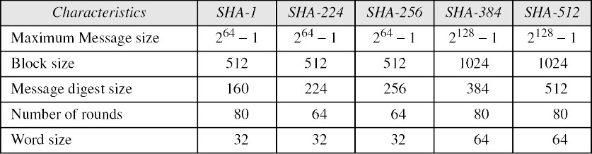

Table 12.1 Characteristics of Secure Hash Algorithms (SHAs)

#### Hash Functions Based on Block Ciphers

An iterated cryptographic hash function can use a symmetric-key block cipher as a compression function. The whole idea is that there are several secure symmetric-key block ciphers, such as triple DES or AES, that can be used to make a one-way function instead of creating a new compression function. The block cipher in this case only performs encryption. Several schemes have been proposed. We later describe one of the most promising, Whirlpool.

**Rabin Scheme** The iterated hash function proposed by Rabin is very simple. The Rabin scheme is based on the Merkle-Damgard scheme. The compression function is replaced by any encrypting cipher. The message block is used as the key; the previously created digest is used as the plaintext. The ciphertext is the new message digest. Note that the size of the digest is the size of data block cipher in the underlying cryptosystem. For example, if DES is used as the block cipher, the size of the digest is only 64 bits. Although the scheme is very simple, it is subject to a meet-in-the-middle attack discussed in chapter 6, because the adversary can use the decryption algorithm of the cryptosystem. Figure 12.2 shows the Rabin scheme.

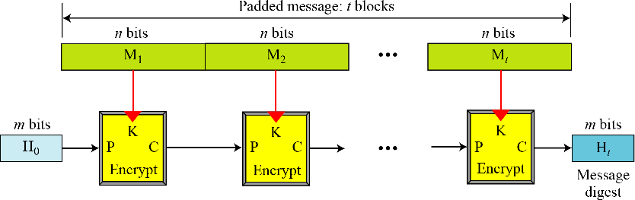

Figure 12.2 Rabin scheme

**Davies-Meyer Scheme** The Davies-Meyer scheme is basically the same as the Rabin scheme except that it uses forward feed to protect against meet-in-the-middle attack. Figure 12.3 shows Davies-Meyer scheme.

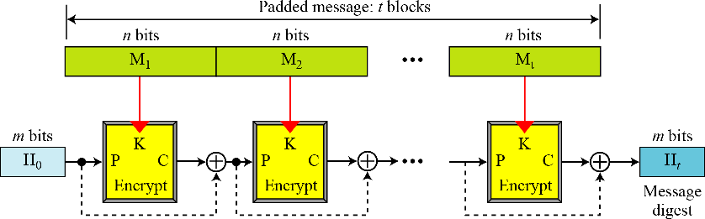

Figure 12.3 Davies-Meyer scheme

**Matyas-Meyer-Oseas Scheme** The Matyas-Meyer-Oseas scheme is a dual version of the Davies-Meyer scheme: the message block is used as the key to the cryptosystem. The scheme can be used if the data block and the cipher key are the same size. For example, AES is a good candidate for this purpose. Figure 12.4 shows the Matyas-Meyer-Oseas scheme.

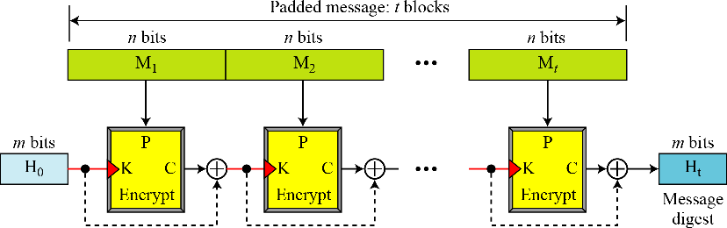

Figure 12.4 Matyas-Meyer-Oseas scheme

**Miyaguchi-Preneel Scheme** The Miyaguchi-Preneel scheme is an extended version of Matyas- Meyer-Oseas. To make the algorithm stronger against attack, the plaintext, the cipher key, and the ciphertext junction. Figure 12.5 shows the Miyaguchi-Preneel scheme.

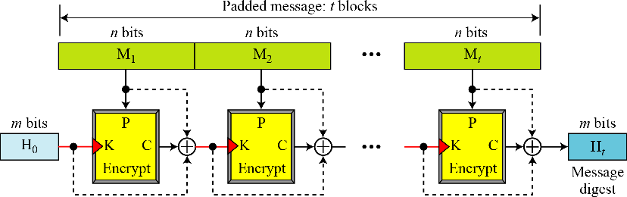

Figure 12.5 Miyaguchi-Preneel scheme

# Description of MD Hash Family

Hash functions of the MD-family are iterated hash functions and follow the MD-design principle. Further, these hash functions share a common structure of the compression function. The compression function consists of two major parts which are the message expansion and the consecutive evaluation of a number of similar operations, called steps. Three steps are usually grouped together into 3-5 rounds. After the last step of the compression function, the input chaining variables are added to the output, which complicates the inversion of the compression function.

# WHIRLPOOL

Whirlpool is designed by Vincent Rijmen and Paulo S. L. M. Barreto. Whirlpool is an iterated cryptographic hash function, based on the Miyaguchi-Preneel scheme that uses a symmetric-key block cipher in place of the compression function. The block cipher is modified AES cipher that has been tailored for this purpose. Figure 12.6 shows the Whirlpool hash function.

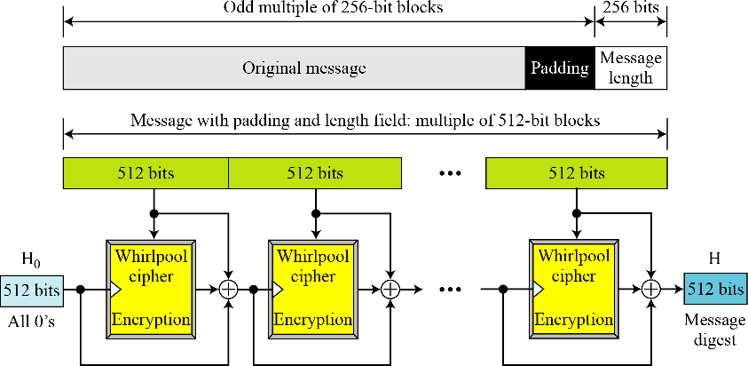

Figure 12.6 Whirlpool hash function

**Preparation** Before starting the hash algorithm, the message needs to be prepared for processing. Whirlpool required that the length of the original message be less than 2256 bits. A message needs to be padded before being processed. The padding is a single 1-bit followed by the necessary numbers of 0-bits. To make the length of the padding an odd multiple of 256 bits. After padding, a block of 256 bits is added to define the length of the original message. This block is treated as an unsigned number.

After padding and adding the length field, the augmented message size is an even multiple of 256 bits or a multiple of 512 bits. Whirlpool creates a digest of 512 bits from a multiple of 512-bit block message. The 512-bit digest, H0, is initialized to all 0’s. This value because the cipher key for encrypting the first block. The ciphertext resulting from encryption each block become the cipher key for the next block after being exclusive-ored with the previous cipher key and the plaintext block. The message digest is the final 512-bit ciphertext after the last exclusive-or operation.

### Whirlpool Cipher

The Whirlpool cipher is a non-Feistel cipher like AES that was mainly designed as a block cipher to be used in a hash algorithm. Instead of giving the whole description of this cipher, we just assume

that the reader is familiar with AES from chapter 7. Here the Whirlpool cipher is compared with the AES cipher and their differences are mentioned.

**Rounds** Whirlpool is a round cipher that uses 10 rounds. The block size and key size are 512 bits. The cipher uses 11 round keys, K0 to K10, each of 512 bits. Figure 12.7 shows the general design of the Whirlpool cipher.

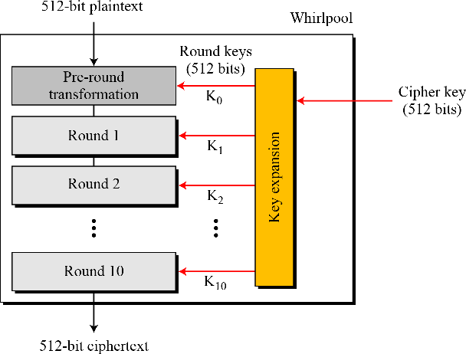

Figure 12.7 General idea of the Whirlpool cipher

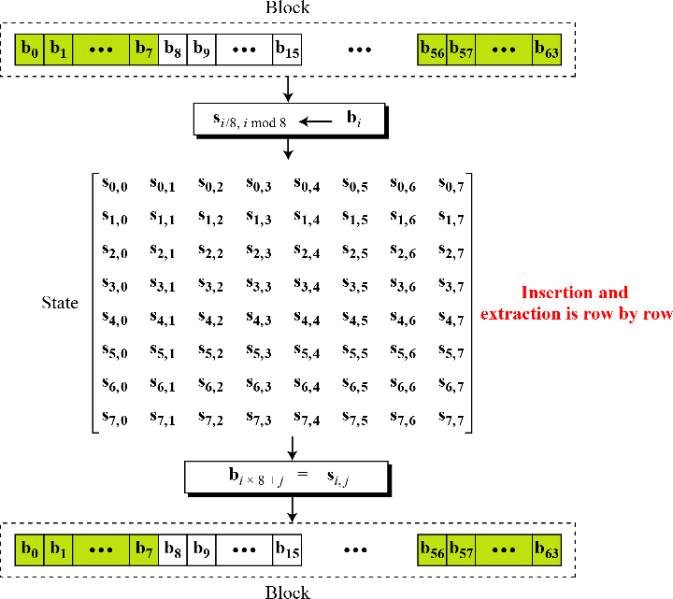

Figure 12.8 Block and state in the Whirlpool cipher

**States and Blocks** Like the AES cipher, the Whirlpool cipher uses states and blocks. However, the size of the block or state is 512 bits. A block is considered as a row matrix of 64 bytes; a state is considered as a square matrix of 8 x 8 bytes. Unlike AES, the block-to-state or state-to-block transformation is done row by tow. Figure 12.8 shows the block, the state, and the transformation in the Whirlpool cipher.

**Structure of each round** Figure 12.9 shows the structure of each round. Each round uses four transformations.

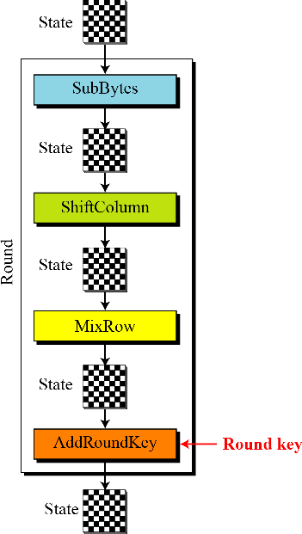

Figure 12.9 Structure of each round in the Whirlpool cipher

**SubBytes** Like in AES, SubBytes provide a nonlinear transformation. A byte is represented as two hexadecimal digits. The left digit defines the row and the right digit defines the column of the substitution table. The two hexadecimal digits at the junction of the row and the column are the new byte. Figure 12.10 shows the idea.

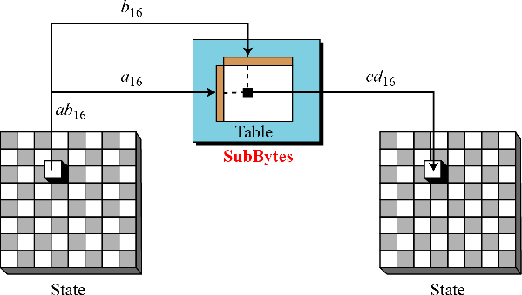

Figure 12.10 SubBytes transformations in the Whirlpool cipher



In the SubBytes transformation, the state is treated as an 8 x 8 matrix of bytes. Transformation is done one byte at a time. The contents of each byte are change, but the arrangement of the bytes in the matrix remains the same. In the process, each byte is transformed independently; we have 64 distinct byte-to-byte transformations.

Table 12.2 shows the substitution table (S-Box) for SubBytes transformation. The transformation definitely provides confusion effect. For example, two bytes 5A16 and 5B16, which differ only in one bit (the rightmost bit), are transformed to 5B16 and 8816,which differ in five bits.

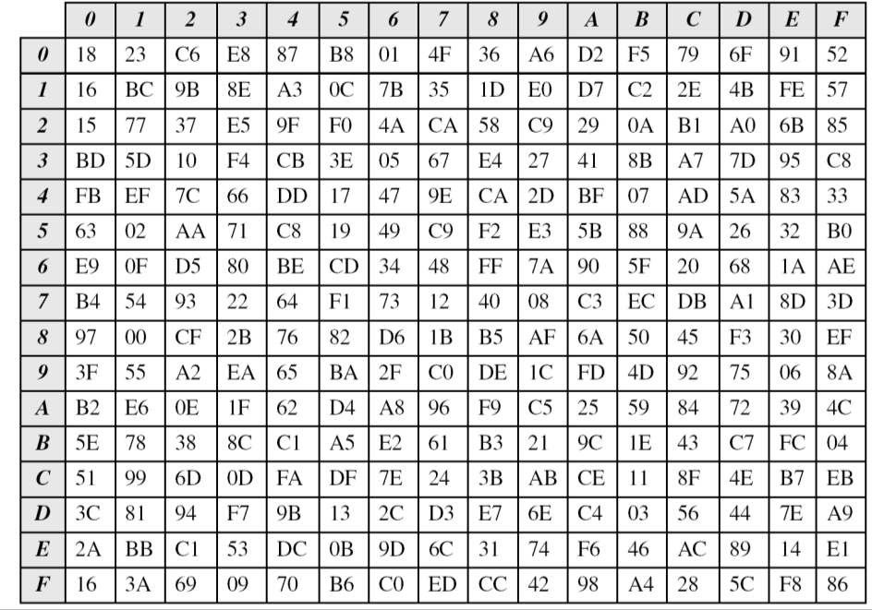

Table 12.2 SubBytes transformation table (S-Box)

**ShiftColumns** To provide permutation, Whirlpool uses the ShiftColumns transformation, which is similar to the ShiftRows transformation in AES, except that the columns instead of rows are shifted. Shifting depends on the position of the column. Column 0 goes through 0-byte shifting (no shifting), while column 7 goes through 7-byte shifting. Figure 12.11 shows the shifting transformation.

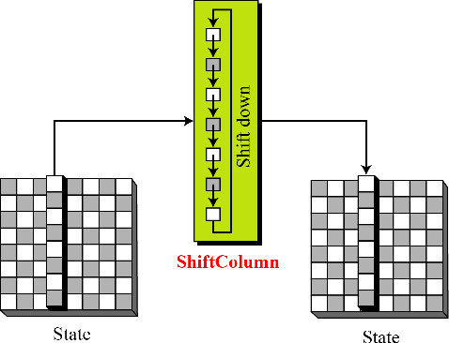

Figure 12.11 ShiftColumns transformation in the Whirlpool cipher

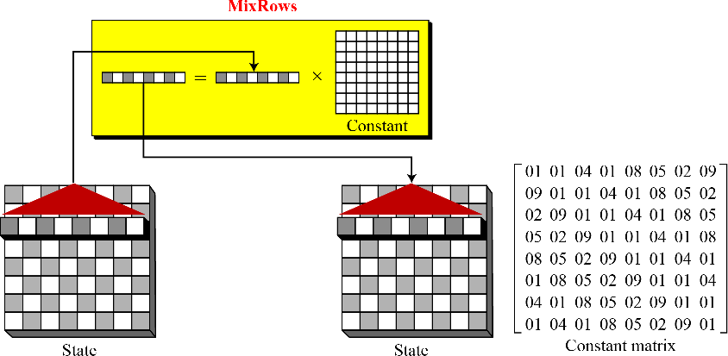**MixRows** The MixRows transformation has the same effect as the MixColumns transformation in AES; it diffuses the bits. Figure 12.12 shows the MixRows transformation.

Figure 12.12 MixRows transformation in the Whirlpool cipher

The figure 12.12 shows multiplication of a single row by the constant matrix; the multiplication can actually be done by multiplying the whole state by the constant matrix, each row is the circular right shift of the previous row.

**AddRoundKey** The Add RoundKey transformation in the Whirlpool cipher is done byte by byte, because each round key is also a state of an 8 x 8 matrix. Figure 12.13 shows the process.

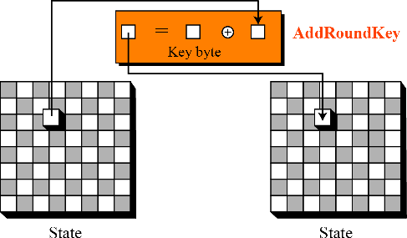

Figure 12.13 AddRoundKey transformation in the Whirlpool cipher

#### Key Expansion

As figure 12.14 shows, the key-expansion algorithm in Whirlpool is totally different from the algorithm in AES. Instead of using a new algorithm for creating round keys, Whirlpool uses a copy of the encryption algorithm (without the pre-round) to create the round keys. The output of each round in the encryption algorithm is the round key for that round. The key-expansion algorithm uses 10 round constants (RCs) as the round keys and the encryption algorithm uses the output of each round of the key-expansion algorithm as the round keys. The key-generation algorithm treats the cipher key as the plaintext and encrypts it. Note that the cipher key is also K0 for the encryption algorithm.



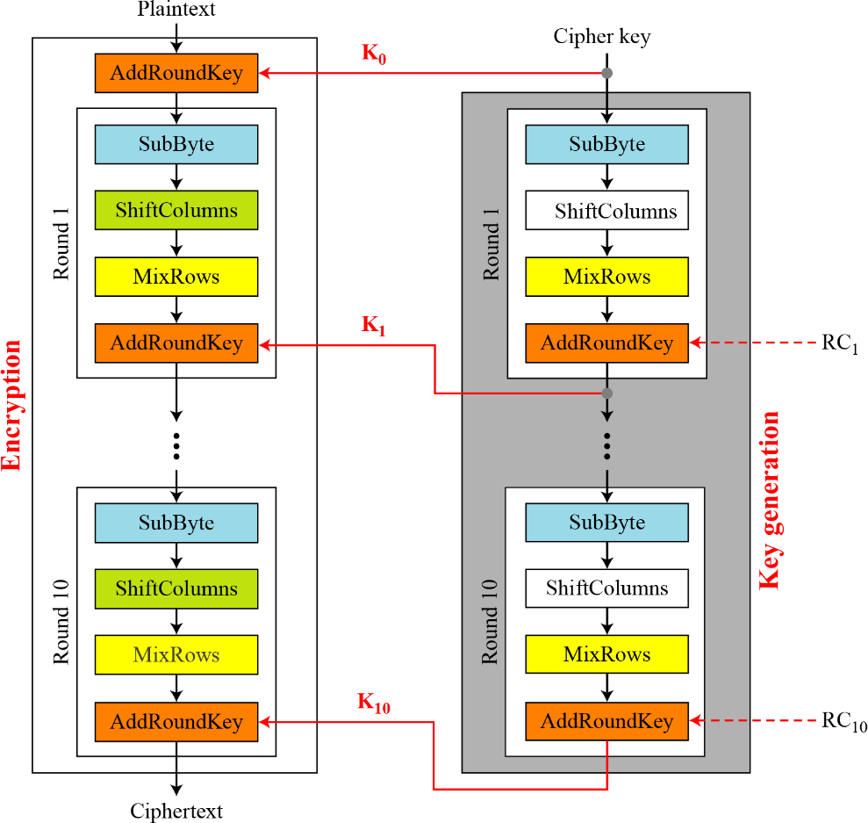

Figure 12.14 Key expansion in the Whirlpool cipher

**Round Constants** Each round constant, RCr is an 8 x 8 matrix where only the first row has non-zero values. The rest of the entries are all 0’s. The values for the first row of RC1 uses the first eight entries in the SubBytes transformation table 12.2. In other words, RC1 uses the first eight entries in the SubBytes transformation table [Table 12.2]; RC2 uses the second eight entries, and so on. For example, figure 12.15 shows RC3, where the first row is the third eight entries in the SubBytes table.

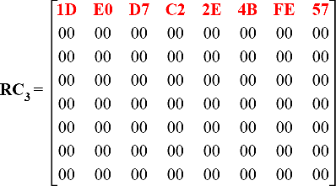

Figure 12.15 Round constant for the third round Table 12.3 shows the main characteristics of the Whirlpool cipher.

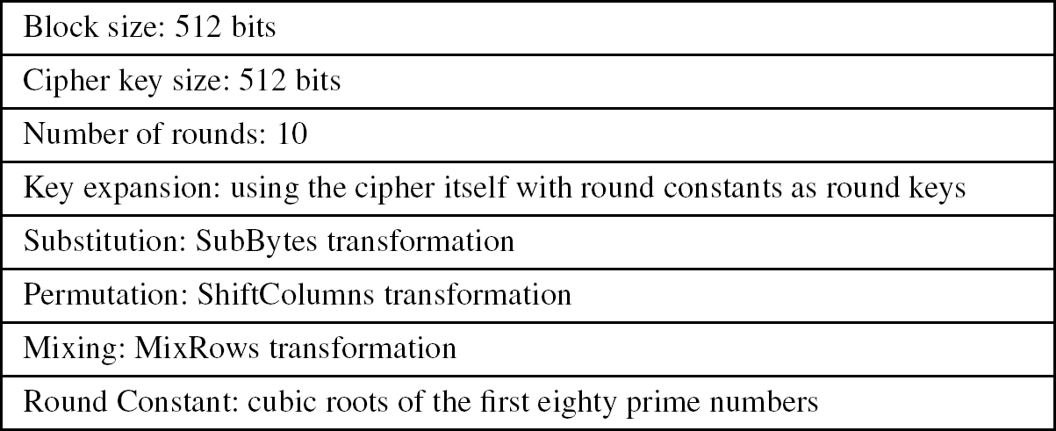

Table 12.3 The main characteristics of the Whirlpool cipher.

**Analysis** Although Whirlpool has not been extensively studied or tested, it is based on a robust scheme (Miyaguchi-Preneel), and for a compression function uses a cipher that is based on AES, a cryptosystem that has been proved very resistant to attacks In addition, the size of the message digest is the same as for SHA-512. Therefore it is expected to be a very strong cryptographic hash function. However, more testing and researches are needed to confirm this. The only concern is that Whirlpool, which is based on a cipher as the compression function, may not be as efficient as SHA- 512, particularly when it is implemented in hardware.

# SHA-5l2

SHA-512 is the version of SH with a 512-bit message digest. This is designed based on the Merkle- Damgard scheme. It is the latest version, it has a more complex structure than the others, and its message digest is the longest.

|  |  |
| --- | --- |
| Characteristics | SHA-512 |
| Maximum Message size | 2128 - 1 |
| Block size | 1024 |
| Message digest size | 512 |
| Number of rounds | 80 |
| Word size | 64 |

Table 12.4 Characteristic of SHA-512

### Introduction

SHA creates a digest of 512 bits from a multiple-block message. Each block is 1024 bits length, as shown in figure 12.16.

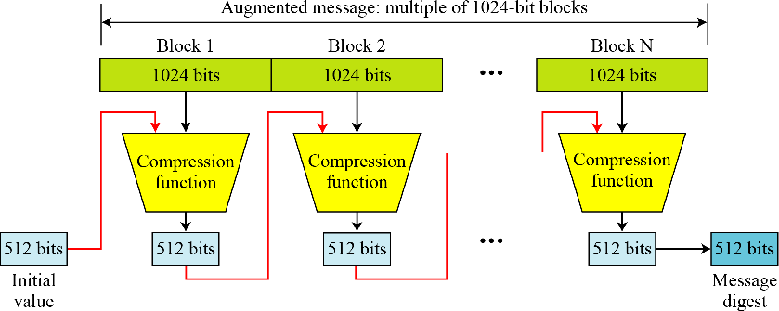

Figure 12.16 Message digest creation SHA-512



The digest is initialized to a predetermined value of 512-bits. The algorithm mixes this initial value with the first block of the message to create the first intermediate message digest of 512 bits. The digest is then mixed with the second block to create the second intermediate digest. Finally, the (N-1)th digest is mixed with the Nth block to create the Nth digest. When the last block is processed, the resulting digest is the message digest for the entire message.

#### Message Preparation

SHA-512 insists that the length of the original message be less than 2128 bits. This is not usually a problem because 2128 bits is probably larger than the total storage capacity of any system.

**Length Field and Padding** Before the message digest can be created, SHA-512 requires the addition of a 128-bit unsigned-integer length field to the message that defines the length of the message in bits. This is the length of the original message before padding. The length field defines the length of the original message before adding the length field or the padding (figure 12.17).

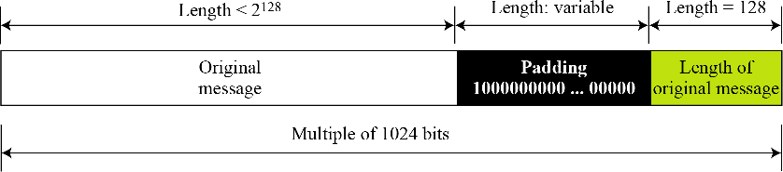

Figure 12.17 Padding and length field in SHA-512

Before the addition of the length field, we need to pad the original message to make the length a multiple of 1024. We reserve 128 bits for the length field, as shown in Figure. The length of the padding field can be calculated as follows.

Let |M| be the length of the original message and |P| be the length of the padding field

(|M| + |P| + 128) = 0 mod 1024 → |P| = (-|M| - 128) mod 1024 The format of the padding is one 1 followed by number of 0s. (Ex: 1000000000…..)

**Example:**

**What is the number of padding bits if the length of the original message is 2590 bits in SHA- 5l2?**

Solution:

We can calculate the number of padding bits as follows:

|P| = (-2590 - 128) mod 1024 = -2718 mod 1024 = 354

The padding consists of one 1 followed by 353 0’s.

**Words** SHA-512 operates on words; it is word oriented. A word is defined as 64 bits. This means that, after the padding and the length field are added to the message, each block of the message consists of sixteen 64-bit words. The message digest is also made of 64-bit words, but the message digest is only eight words and the words are named A, B, C, D, E, F, G, and H, as shown in figure 12.18.

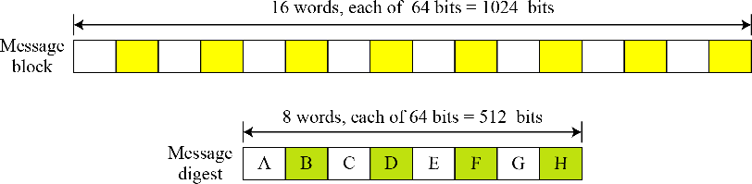

Figure 12.18 A message block and the digest as words

SHA-512 is word-oriented. Each block is 16 words; the digest is only 8 words.

**Word Expansion** Before processing, each message block must be expanded. A block is made of 1024 bits, or sixteen 64-bit words. As we will see later, we need 80 words in the processing phase. So the 16-word block needs to be expanded to 80 words, from W0 to W79. Figure 12.19 shows the word-expansion process. The 1024-bit block becomes the first 16 words; the rest of the words come from already-made words according to the operation shown in the figure.

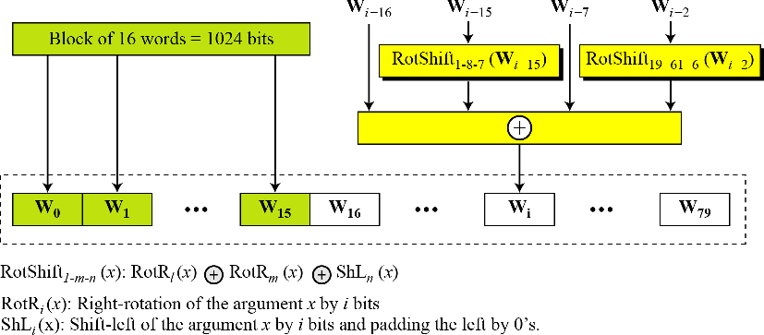

Figure 12.19 Word expansion in SHA-512

**Example:**

**Show how W60 is made.**

Solution:

Each word in the range W16 to W79 is made from four previously-made words. W60 is made as

**Message Digest Initialization** The algorithm uses eight constants for message digest initialization. We call these constants A0 to H0 to match with the word naming used for the digest. Table 12.5 shows the value of these constants.



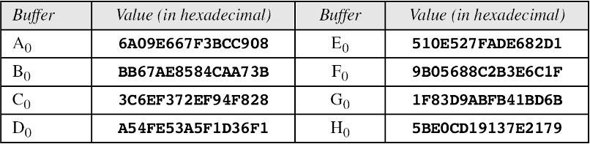

Table 12.5 Values of constants in message digest initialization of SHA-512

The values are calculated from the first eight prime numbers (2, 3, 5, 7, 11, 13, 17, and 19). Each value is the fraction part of the square root of the corresponding prime number after converting to binary and keeping only the first 64-bits. For example, the eighth prime is 19, with the square root (19)½ = 4. 35889894354. Converting the number to binary with only 64 bits in the fraction part, we get

(100.0101 1011 1110 … 1001)2 = (4.5BE0CD19137E2179)16

SHA-512 keeps the fraction part, (5BE0CD19137E2179)16, an unsigned integer.

### Compression Function

SHA-512 creates a 512-bit (eight 64-bit words) message digest from a multiple-block message where each block is 1024 bits. The processing of each block of data in SHA-512 involves 80 rounds. Figure

12.20 shows the general outline for the compression function. In each round, the contents of eight previous buffers, one word from the expanded block (Wi), and one 64-bit constant (Ki) are mixed together and then operated on to create a new set of eight buffers. At the beginning of processing, the values of the eight buffers are saved into eight temporary variables. At the end of the processing (after step 79), these values are added to the values created from step 79. We call this last operation the final adding, as shown in figure 12.20.

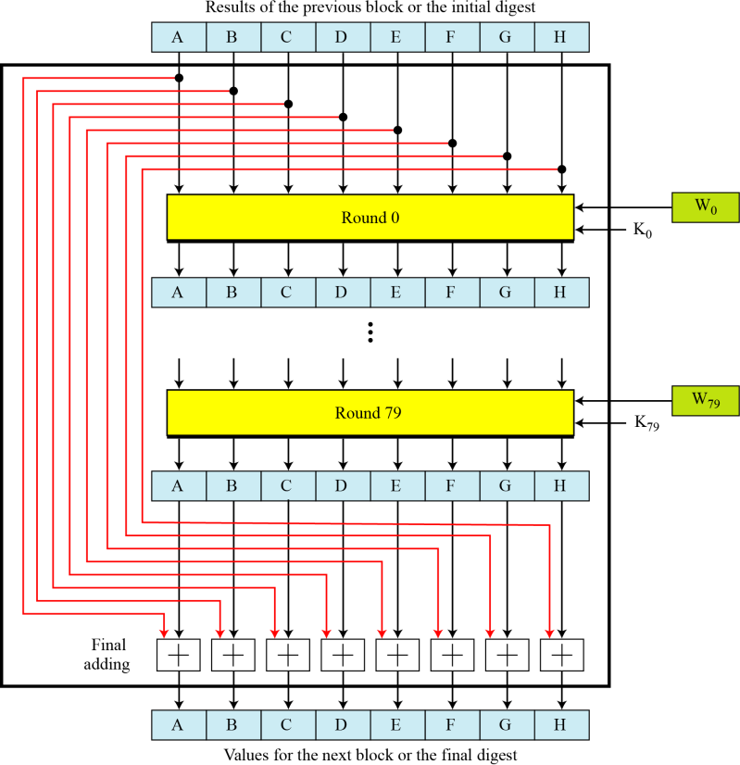

Figure 12.20 Compression function in SHA-512

#### Structure of each Round

In each round, eight new values for the 64-bit buffers are created from the values of the buffers in the previous round. As figure 12.21 shows, six buffers are the exact copies of one of the buffers in the previous round as shown below:

A → B B → C C → D E → F F → G G → H

Two of the new buffers, A and E, receive their inputs from some complex functions that involve some of the previous buffers, the corresponding word for this round (Wi), and the corresponding constant for this round (Ki). Figure shows the structure of each round.

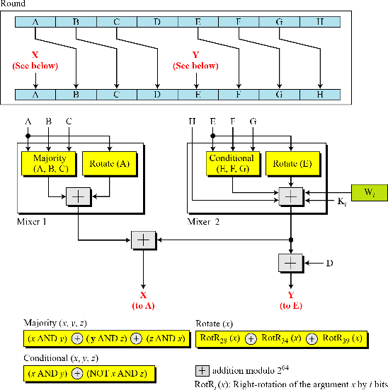

Figure 12.21 Structure of each round in SHA-512

There are two mixers, three functions, and several operators. Each mixer combines two functions. The description of the functions and operators follows:

1. The Majority function, as we call it, ***if two or three bits are 1’s (in Ai, Bi, and Ci), then the resulting bit is 1; otherwise it is 0.***

We can write it in bitwise function as

(Aj and Bj) ⊕ (Bj and Cj) ⊕ (Cj and Aj)

1. The Conditional function, as we call it, is also a bitwise function. It takes three corresponding bits in three buffers (E, F, and G) and calculates

(Ej AND Fj) ⊕ (NOT Ej and Gi)

The resulting bit is the logic “**if Ej then Fj; else Gj**”.

1. The rotate function, as we all it, right-rotates the three instances of the same buffer (A or E) and applies the exclusive-or operation on the results.

Rotate (A): RotR28(A) ⊕ RotR34(A) ⊕ RotR29(A)

Rotate (E): RotT28(E) ⊕ RotR34(E) ⊕ RotR29(E)

1. The right-rotation function, RotRi(x), is the same as the one we used in the word-expansion process. It right-rotates its argument i bits; it is actually a circular shift-right operation.
2. The addition operator used in the process is addition modulo 264. This means that the result of adding two or more buffers is always a 64-bit word.
3. There are 80 constants, K0 to K79, each of 64 bits as shown in table 12.6 in hexadecimal format. Similar to the initial values for the eight digest buffers, these values are calculated from the first 80 prime numbers (2, 3, … , 409).

Each value is the fraction part of the cubic root of the corresponding prime number after converting it to binary and keeping only the first 64 bits. For example, the 80th prime is 409, with the cubic root (409)⅓ = 7.42291412044. Converting this number to binary with only 64 bits in the fraction part, we get

(111.0110 1100 0100 0100…0111)2 → (7.6C44198C4A475817)16

SHA-512 keeps the fraction part, (6C44198C4A475817)16, as an unsigned integer.

**Analysis** With a message digest of 512 bits, SHA-512 expected to be resistant to all attacks, including collision attacks. It has been claimed that this version’s improved design makes it more efficient and more secure that the previous versions.

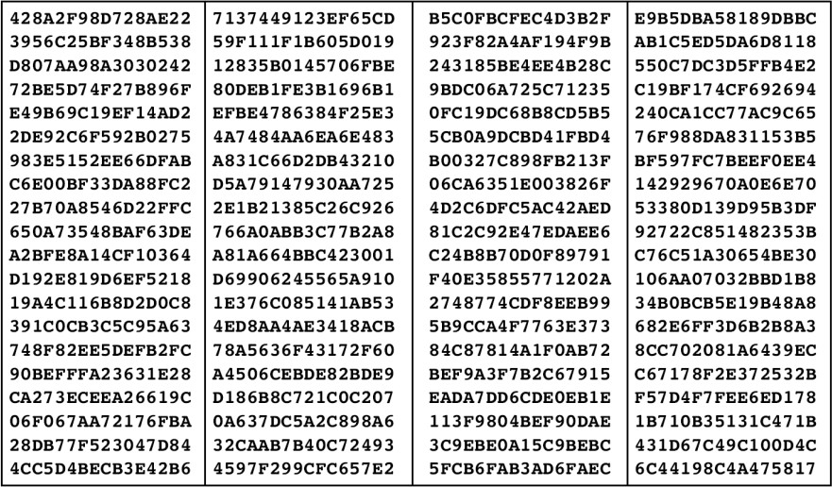

Table 12.6 Eighty constants used for eighty rounds in SHA-512

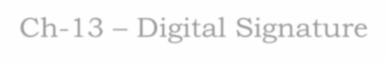

Ch-13 – Digital Signature

# l. Comparison

Let us begin by looking at the differences between conventional signatures and digital signatures.

### Inclusion

* + - A conventional signature is included in the document; it is part of a document.
    - When we write a check, the signature is on the check; it is not a separate document. But when we sign a document digitally, we send the signatures as a separate document.
    - The sender sends two documents; the message and the signature.
    - The recipient receives both document and verifies that the signature belongs to the supposed sender.
    - If this is proven, the message is kept; otherwise, it is rejected.

### Verification method

* + - The second difference between the two types of signatures is the method of verifying the signature.
    - For a conventional signature, when the recipient receives a document, she compares the signature on the document with the signature on file.
    - If they are the same, the document is authentic.
    - The recipient needs to have a copy of this signature on file for comparison.
    - For a digital signature, the recipient receives the message and the signature.
    - A copy of the signature is not stored anywhere.
    - The recipient needs to apply a verification technique to combination of the message and the signature to verify the authenticity.

### Relationship

* + - For a conventional signature, there is normally a one- to-many relationship between a signature and documents.
    - A person uses the same signature to sign many documents.
    - For a digital signature, there is a one-to-one relationship between a signature and a message.
    - Each message has its own signature.
    - The signature of one message cannot be used in another message.
    - If Bob receives two messages, one after another, from Alice, he cannot use the signature of the first message to verify the second.
    - Each message needs a new signature.

### Duplicity

* + - Another differences between the two types of signatures is a quality called duplicity.
    - In conventional signature, a copy of the signed document can be distinguished from the original one on file.
    - In digital signature, there is no such distinction unless there is a factor of time (such as a timestamp) on the document.
    - For example, suppose Alice sends a document instructing Bob to pay Eve.
    - If Eve intercepts the document and the signature, she can replay it later to get money again from Bob.

# Process

* + Figure 13.1 shows the digital signature process. The sender uses a signing algorithm to sign the message.
  + The message and the signature are sent to the receiver. The receiver receives the message and the signature and applies the verifying algorithm to the combination.
  + If the result is true, the message is accepted; otherwise, it is rejected.

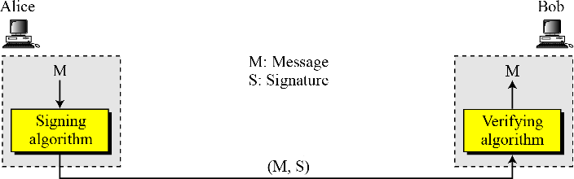

Figure 13.1 Digital signature process

### Need for Keys

* + - In a digital signature, the signer uses her private key, applied to a signing algorithm to sign the document.
    - 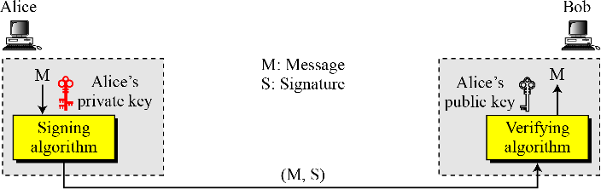The verifier, on the other hand, uses the public key of the signer, applied to the verifying algorithm, to verify the document. See Figure 13.2.

Figure 13.2 Adding key to the digital signature process

A digital signature needs a public-key system. The signer signs with her private key; the

verifier verifies with the signer’s public key.

A cryptosystem uses the public key and private of receiver; a digital signature uses the private and public keys of the sender.

### Signing the digest

Figure 13.3 shows signing a digest in a digital signature system.

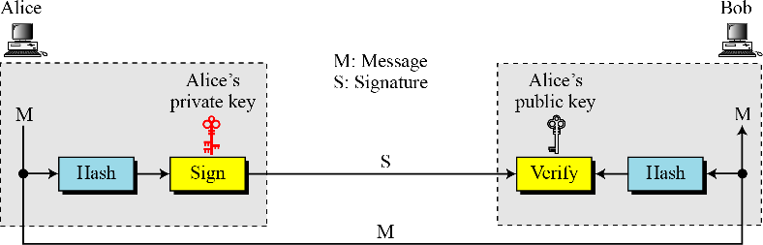

Figure 13.3 Signing the digest

* + - A digest is made out of the message at Alice’s site. The digest then goes through the signing

process using Alice’s private key. Alice then sends the message and the signature to Bob.

* + - At Bob’s site, using the same public hash function, a digest is first created out of the received message. Calculations are done on the signature and the digest. The verifying process also applies criteria on the result of the calculation to determine the authenticity of the signature. If authentic, the message is accepted; otherwise it is rejected.

# Services provided by digital signature

A digital signature can directly provide the message authentication, message integrity and non-repudiation; for message confidentiality we still need encryption/decryption.

### Message Authentication

A secure digital signature scheme, like a secure conventional signature (one that cannot be copied) can provide message authentication (also referred to as data-origin authentication). Bob can verify that the message is sent by Alice because Alice’s public key is used in verification. Alice’s public key cannot verify the signature signed by the Eve’s private key.

### Message Integrity

The integrity of the message is preserved even if we sign the whole message because we cannot get the same signature if the message is changed. The digital signature schemes today use a hash function in the signing and verifying algorithms that preserve the integrity of the message.

### Nonrepudiation

If Alice signs a message and then denies it, can Bob later prove that Alice actually signed it? For example, If Alice sends a message to a bank (Bob) and asks to transfer $10,000 from her account to Ted’s account, can Alice later deny that she sent this message? Bob might have a problem. Bob must keep the signature on file and later use Alice’s public key to create the original message to prove the message in the file and later use Alice’s public key to create the original message to prove the message in the file and the newly created message are the same. This is not feasible because

Alice may have changed her private or public key during this time; she may also claim that the file containing the signature is not authentic.

One solution is a trusted third party. People can create an established trusted party among themselves. Figure 13.4 shows how a trusted party can present Alice from denying that she sent the message.

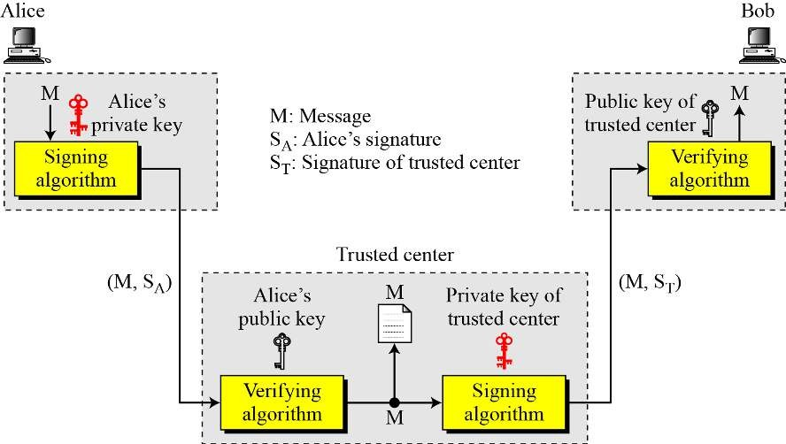

Figure 13.4 Using a trusted center for nonrepudiation

### Confidentiality

* + - A digital signature does not provide confidential communication
    - If confidentiality is required, the message and the signature must be encrypted using either a secret-key or public-key cryptosystem. Figure 13.5 shows how this extra level can be added to a simple digital signature scheme.

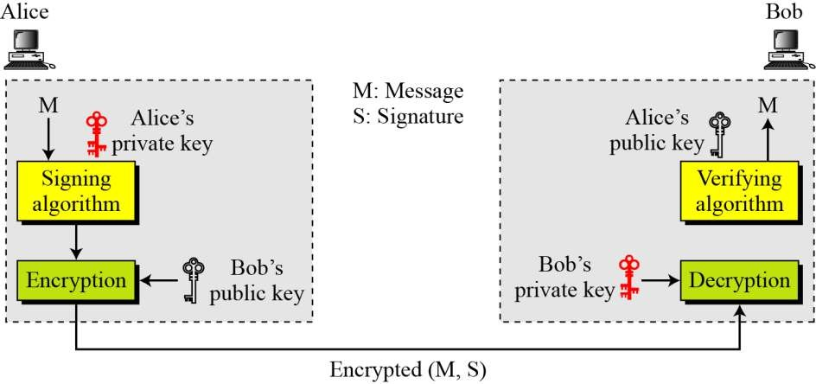

Figure 13.5 Adding confidentiality to a digital signature scheme

* + - We have shown asymmetric key encryption/decryption just to emphasize the type of keys used at each end. Encryption/decryption can also be done with as symmetric key.

A digital signature does not provide privacy. If there is a need for privacy, another layer of encryption/decryption must be applied.

# ATTACKS ON DIGITAL SIGNATURE

### Attack types

We will look on three kinds of attacks on digital signatures; key-only, known message and chosen- message.

#### Key-Only Attack

* + - In this, Eve has access only to the public information released by Alice. To forge a message, she has access to some documents previously signed by Alice.
    - Eve tries to create another message and forge Alice’s signature on it.
    - This is similar to the known-plaintext attack we discussed for encipherment.

#### Known-Message Attack

* + - In this, Eve has access to one or more message signature pairs.
    - In-other words, she access to some documents previously signed by Alice.
    - Eve tries to create another message and forge Alice’s signature on it.
    - This is similar to the known-plaintext attack we discussed for encipherment.

#### Chosen-Message Attack

* + - In the chosen-message attack, Eve somehow makes Alice sign one or more messages of her.
    - Eve now has a chosen-message/signature pair.
    - Eve later creates another message, with the content she wants, and forge Alice’s signature

on it.

* + - This is similar to the chosen-plaintext attack we discussed for encipherment.

### Forgery Types

If the attack is successful, the result is a forgery. We can have two types of forgery: existential and selective.

#### Existential Forgery

* + - In an existential forgery, Eve may be able to create a valid message-signature pair, but not one that she can really use.
    - In other words, a document has been forged, but the content is randomly calculated.
    - This type of forgery is probable, but fortunately Eve cannot benefit from it very much.
    - Her message could be syntactically or semantically unintelligible.

#### Selective Forgery

* + - In selective forgery, Eve may be able to forge Alice’s signature on a message with the content

selectively chosen by Eve.

* + - Although this is beneficial to Eve, and may be very detrimental to Alice, the probability of such forgery is low, but not negligible.

# Digital Signature Schemes

### RSA Digital Signature Scheme

In chapter 10 we discussed how to use RSA cryptosystem to provide privacy. The RSA idea can also be used for signing and verifying a message. In this case, it is called the RSA digital signature scheme. The sender uses her own private key to sign the document; the receiver uses the sender’s public key to verify it. Figure 13.6 gives the general idea behind the RSA digital signature scheme.

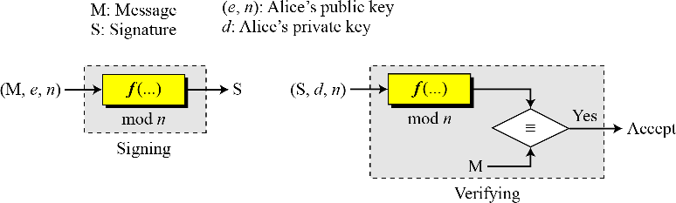

Figure 13.6 General idea behind the RSA digital signature scheme

* + - The signing and verifying sites uses the same function, but with different parameters.
    - The verifier compares the message and the output of the function for congruence.
    - If the result is true, the message is accepted.

**Key Generation**

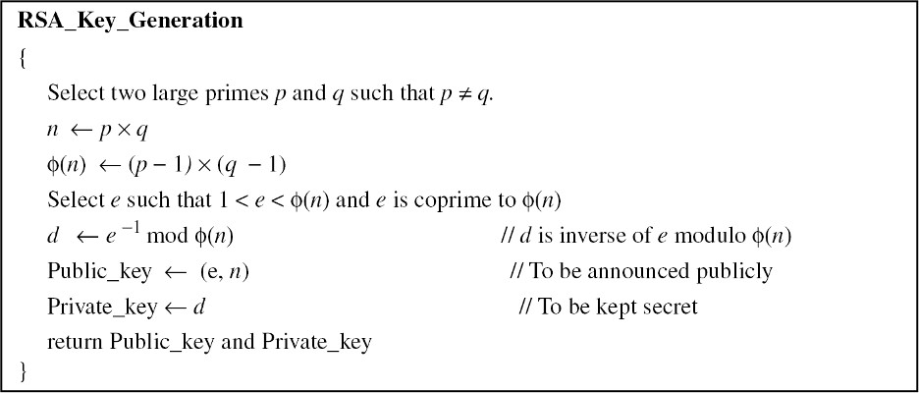

Alice keeps d; she publicly announces n and e.

## Signing and Verifying

Figure 13.7 shows the RSA digital signature scheme.

**Signing** Alice creates a signature out of the message using her private exponent, S= Md mod n and sends the message and the signature to Bob.

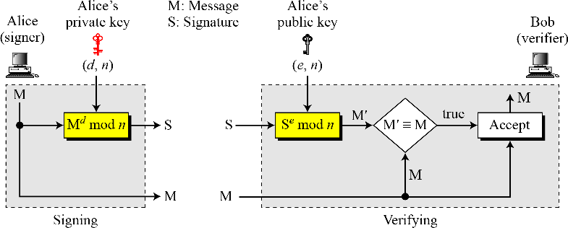

Figure 13.7 RSA digital signature scheme

## Verifying

* + - Bob receives M and S, Bob applies Alice’s public exponent to the signature to create a copy of the message M' = Se mod n.
    - Bob compares the value of M' with the value of M.
    - If the two values are congruent, Bob accepts the message.
    - To prove this, we start with the verification criteria:

M' = M mod n. → Se ≡ M mod n → Md×e ≡ M (mod n)

The last congruent holds because d x e = 1 mod (n) (See Euler’s theorem in chapter 9)

### Attacks on RSA Signature

There are some attacks that Eve can apply to the RSA digital signature scheme to forge Alice’s

signature.

#### Key-only attack

* + - Eve has access only to Alice’s public key.
    - Eve intercepts the pair (M, S) and tries to create another message M' = Se (mod n).

#### Known-Message attack

* + - Here Eve uses the multiplicative property of RSA.
    - Assume that Eve has intercepted two message-signature pair (M1, S1) and (M2, S2) that have been created using the same private key.
    - If M = (M1× M2) mod n, then S = (S1 × S2) mod n

S = (S1 x S2) mod n = (M1d x M2d) mod n = (M1 x M2)d mod n = Md mod n

#### Chosen Message Attack

This attack also uses the multiplicative property of RSA. Eve can somehow ask Alice to sign two legitimate messages, M1 and M2, for her and later creates a new message M = M1 x M2. Eve can later claim that Alice has signed M. The attack is also referred to as multiplicative attack. This is a very

serious attack on the RSA digital signature scheme because it is a selective forgery (Eve can manipulate M1 and M2 to get a useful M).

#### RSA Signature on the Message Digest

As we discussed before, signing a message digest using a strong hash algorithm has several advantages. In the case of RSA, it can make the signing and verifying processes much faster because the RSA digital signature scheme is nothing other than encryption with the private key and decryption with the public key. The use of a strong cryptographic hashing function also makes the attack on the signature much more difficult as we will explain shortly. Figure 13.8 shows the scheme.

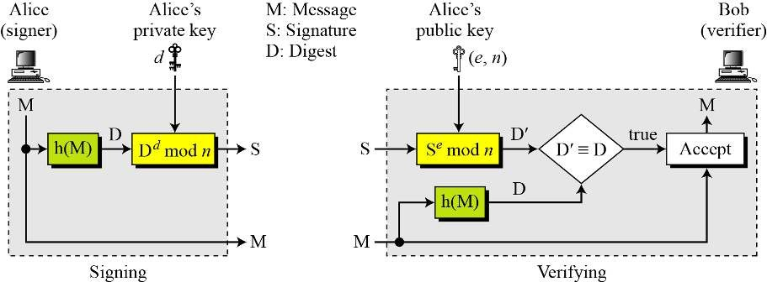

Figure 13.8 The RSA signature on the message digest

Alice, the signer, first uses an agreed-upon hash function to create a digest from the message, D = h(M). She then signs the digest, S = Dd mod n. The message and the signature are sent to Bob. Bob, the verifier, receives the message and the signature. He first uses Alice's public exponent to retrieve the digest, D' = Se mod n. He then applies the hash algorithm to the message received to obtain D = h(M). Bob now compares the two digests, D and D'. If they are congruent to modulo n, he accepts the message.

## Attacks on RSA Signed Digests

**Key Only Attack** We can have three cases of this attack:

1. Eve intercepts the pair (S, M) and tries to find another message M' that creates the same digest, h(M) = h(M'). As we learned in chapter 11, if the hash algorithm is second preimage resistant, this attack is very difficult.
2. Eve finds two messages M and M' such that h(M) = h(M'). She lures Alice to sign h(M) to find S. Now Eve has a pair (M', S) which passes the verifying test, but it is the forgery. We learned in chapter 11 that if the hash algorithm is collision resistant, this attack is very difficult.
3. Eve may randomly find message digest D. which may match with a random signature S. She then finds a message M such that D = h(M). As we learned in Chapter 11, if the hash function is preimage resistant, this attack is very difficult to launch.

**Known Message Attack** Let us assume Eve has two message-signature pairs (M1, S1) and (M2, S2) which have been created using the same private key. Eve calculates S ≡ S1 x S2. If she can find a message M such that h(M) ≡ h(M1) x h(M2), she has forged a new message. However, finding M given h(M) is very difficult if the hash algorithm is preimage resistant.

**Chosen-Message Attack** Eve can ask Alice to sign two legitimate messages M1 and M2 for her. Eve then creates a new signature S ≡ S1 x S2. Since Eve can calculate h(M) ≡ h(M1) x h(M2), if she can find a message M given h(M), the new message is a forgery, However, finding M given h(M), is very difficult if the hash algorithm is preimage resistant.

### ElGamal Digital Signature Scheme

The ElGamal cryptosystem was discussed in chapter 10. The ElGamal digital signature scheme uses the same keys, but the algorithm, as expected, is different. Figure 13.9 gives the general idea behind the ElGamal digital signature scheme.

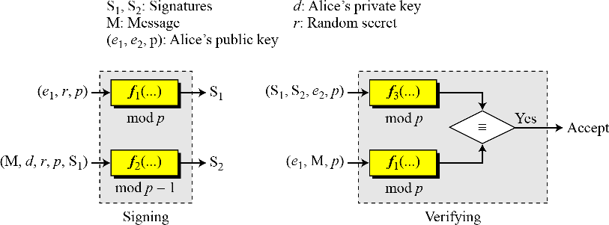

Figure 13.9 General idea behind the ElGamal digital signature scheme

### In the signing process, two functions create two signatures: in the verifying process the outputs of two functions are compared for verification.

* + - Note that one function is used both for signing and verifying but the function uses different inputs.

**Key Generation**

### The key generation procedure here is exactly the same as the one used in the cryptosystem.

* + - Let p be a prime number large enough that the discrete log problem is intractable in Zp*.

### Let e1 be a primitive element in Zp*, Alice selects her private key d to be less than p-1.

* + - She calculates e2=e1d.

### Alice’s public key is the tuple (e1, e2, p); Alice’s private key is d.

#### Verifying and Signing

Figure 13.10 shows the ElGamal digital signature scheme.

#### Signing:

* + - Alice can sign the digest of a message to any entity, including Bob:

1. Alice chooses a secret random number r, public and private keys can be used repeatedly, Alice needs a new r each time the signs a new message.



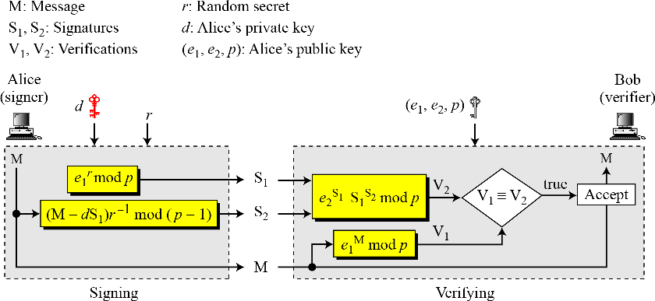

Figure 13.10 ElGamal digital signature scheme

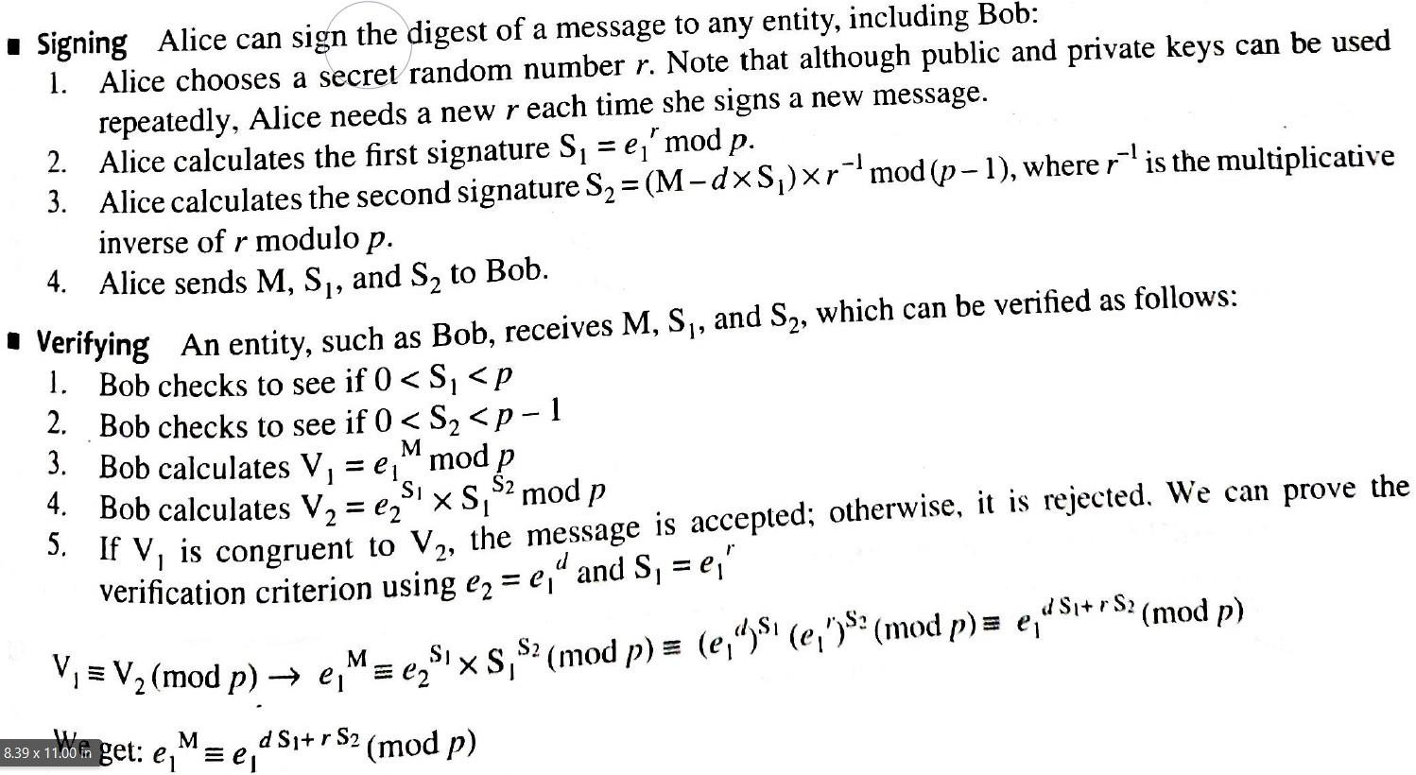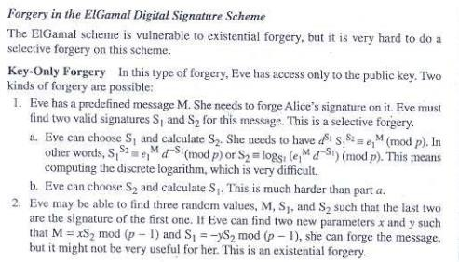



### Schnorr Digital Signature Scheme

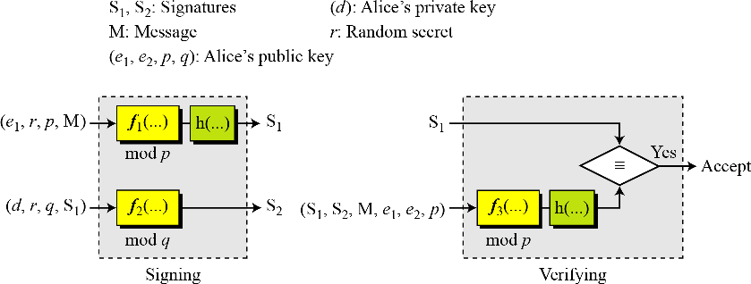

Figure 13.11 General idea behind the Schnorr digital signature scheme Key Generation

1. Alice selects a prime p, which is usually 1024 bits in length.
2. Alice selects another prime q.
3. Alice chooses e1 to be the qth root of 1 modulo p.
4. Alice chooses an integer, d, as her private key.
5. Alice calculates e2 = e1d mod p.
6. Alice’s public key is (e1, e2, p, q); her private key is (d).

#### Signing and Verifying

Figure 13.12 shows the Schnorr digital signature scheme.

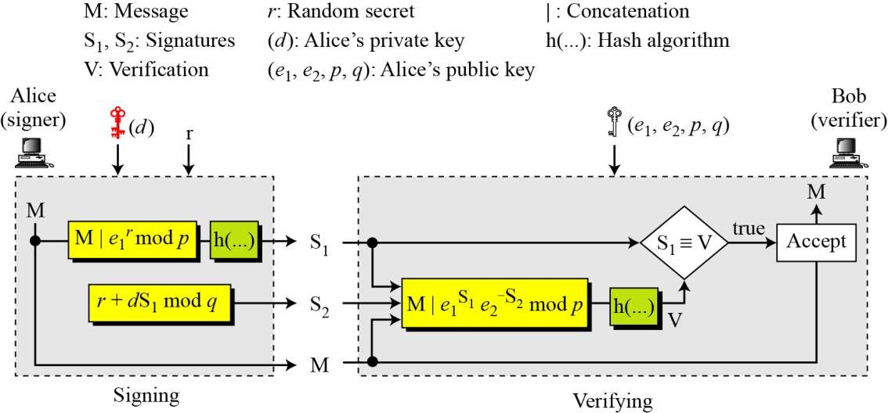

Figure 13.12 Schnorr digital signature scheme

#### Signing

1. Alice chooses a random number r.
2. Alice calculates S1 = h(M|e1r mod p).
3. Alice calculates S2 = r + d × S1 mod q.
4. Alice sends M, S1, and S2.

#### Verifying Message

1. Bob calculates V = h (M | e1S2 e2−S1 mod p).
2. If S1 is congruent to V modulo p, the message is accepted;

### Digital Signature Standard

* + - The Digital Signature Standard (DSS) was adopted by the NIST in 1994.

### DSS uses a DSA based on the ElGamal scheme with some ideas from the Schnorr scheme.

* + - Figure 13.13 gives the general idea behind the DSS scheme.

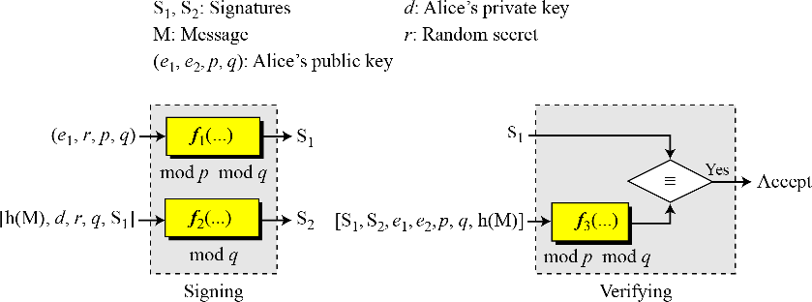

Figure 13.13 General idea behind DSS scheme

#### Key Generation

1. Alice chooses primes p and q.
2. Alice uses <Zp*, × > and <Zq*, ×>.
3. Alice creates e1 to be the qth root of 1 modulo p.
4. Alice chooses d and calculates e2 = e1d.
5. Alice’s public key is (e1, e2, p, q); her private key is (d).

#### Verifying and Signing

Figure 13.14 shows the DSS Scheme.

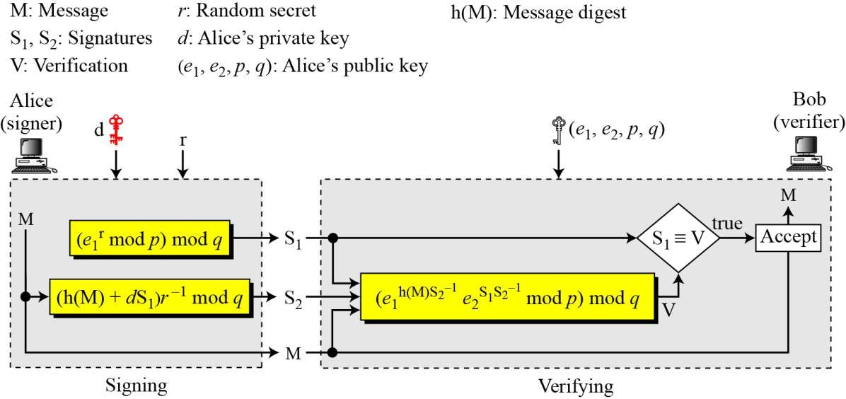

Figure 13.14 DSS scheme

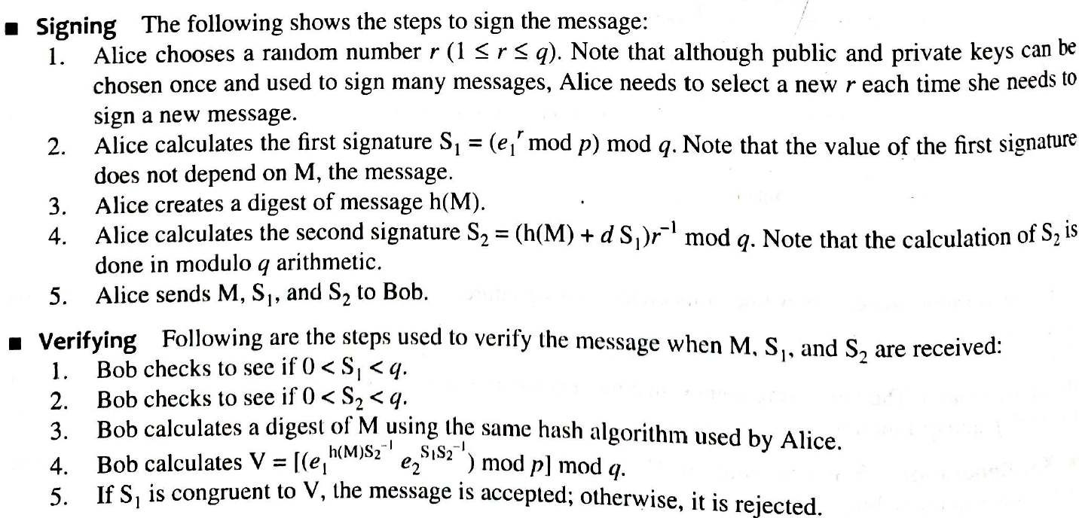

### Elliptic Curve Digital Signature Scheme

Figure 13.15 gives the general idea behind ECDSS.

#### Key Generation

Key generation follows these steps:

1. Alice chooses an elliptic curve Ep(a, b).
2. Alice chooses another prime q the private key d.
3. Alice chooses e1(…, …), a point on the curve.
4. Alice calculates e2(…, …) = d × e1(…, …).
5. Alice’s public key is (a, b, p, q, e1, e2); her private key is d.



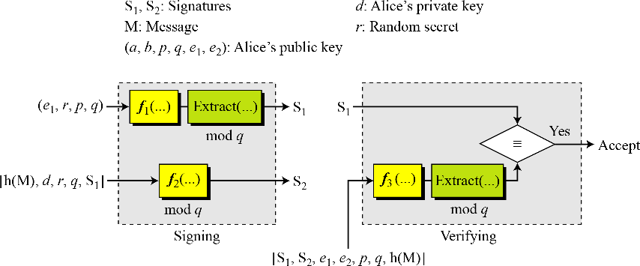

Figure 13.15 General idea behind the ECDSS scheme

#### Signing and Verifying

Figure 13.16 The ECDSS scheme

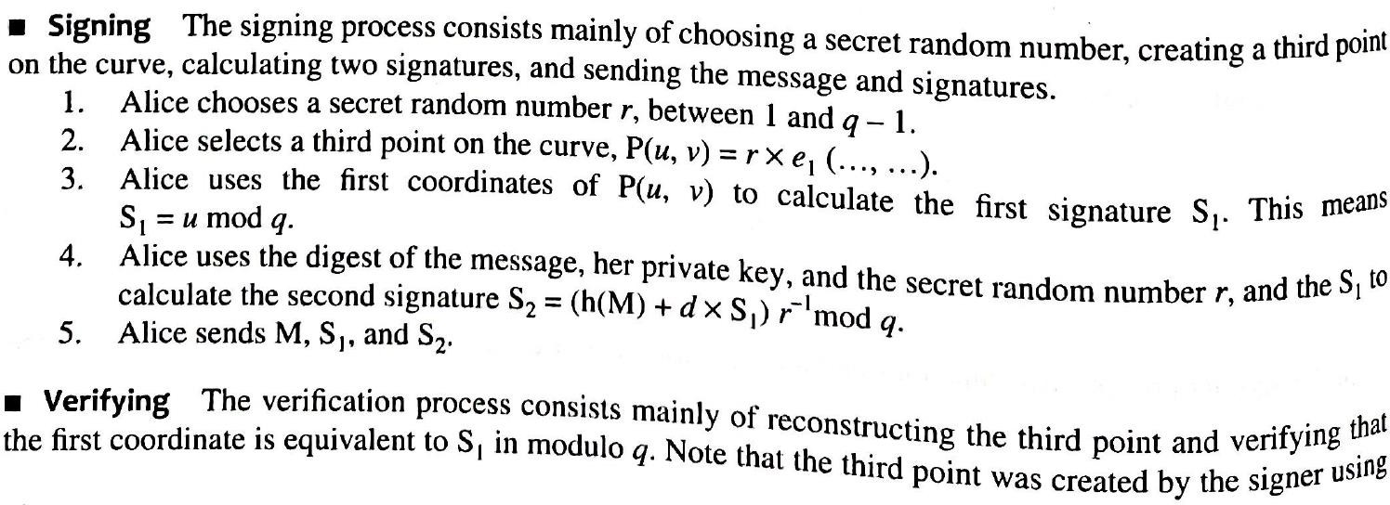

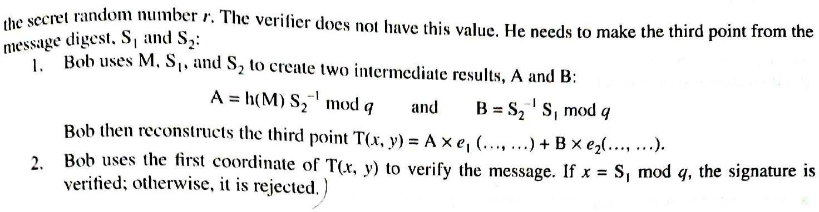

#### DSS Versus RSA

Computation of DSS signatures is faster than computation of RSA signatures when using the same p.

#### DSS Versus ElGamal

DSS signatures are smaller than ElGamal signatures because q is smaller than p.

# Variations and Applications

### Variations

#### Time Stamped Signatures

* + - Sometimes a signed document needs to be timestamped to prevent it from being replayed by an adversary.
    - This is called timestamped digital signature scheme.
    - For example, if Alice signs a request to her Bank, Bob, to transfer some money to Eve, the document can be intercepted and replayed by Eve if there is no timestamp on the document.
    - Including the actual date and time on the documents may create a problem if the clocks are not synchronized and a universal time is not used.
    - One solution is to use a nonce.
    - A nonce is a number that can be used only once, when the receiver receives a document with a nonce, be makes a note that the number is now used by the sender and cannot be used again.
    - In other words, a new nonce defines the “present time”; a used nonce defines “past time”.

#### Blind Signatures:

* + - Sometimes we have a document that we want to get signed without revealing the contents of the document to the signer.
    - David Chaum has developed some patented blind digital signature schemes for this purpose.
    - The main idea is as follows:

1. Bob creates a message and blinds it. Bob sends the blinded message to Alice
2. Alice signs the blinded message and returns the signature on the blinded message.
3. Bob unbinds the signature to obtain a signature on the original message.

#### Undeniable Digital Signatures

* + - * Undeniable digital schemes are elegant inventions of chaum and van Antwerpen.
      * This scheme has three components: a signing algorithm, a verification protocol, and a disavowal protocol.
      * The signing algorithm allows Alice to sign a message.
      * The verification protocol uses the challenge-response mechanism to involve Alice for verifying the signature. This prevents the duplication and distribution of the signed message without Alice’s approval.
      * The disavowal protocol helps Alice deny a forged signature. To prove that signature is forgery, Alice needs to take part in the disavowal protocol.

#### Applications

* + - * Most of these applications directly or indirectly require the use of public keys.
      * To use a public key, a person should prove that she actually owns the public key. For this reason, certificates and certificate authorities (CAs) has been developed.

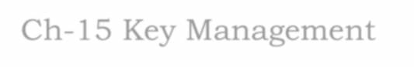

Ch-15 Key Management

# l. Symmetric-key distribution

* Symmetric key cryptography is more efficient than asymmetric key cryptography for enciphering large messages.
* In this, however needs a shared secret key between two parties.
* If Alice needs to exchange confidential messages with N people, she needs N different keys.
* If N people need to communicate with each other, N (N-1)/2 keys are needed.
* The number of keys is not the only problem; the distribution of keys is another. If Alice and Bob want to communicate, they need a way to exchange a secret key.

### Key-Distribution Center: KDC

* + - A practical solution is the use of trusted third party, referred to as a Key- Distribution center (KDC).
    - 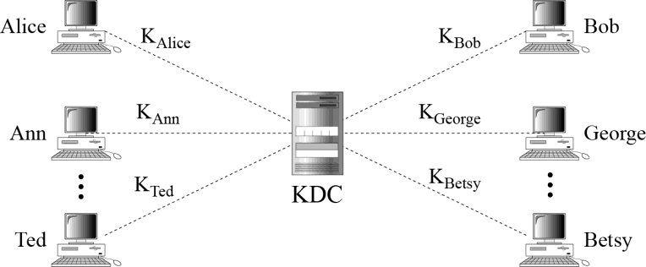To reduce the number of keys, each person establishes a shared secret key with the KDC as shown in figure 15.1.

Figure 15.1 Key-distribution center (KDC)

* + - A secret key is established between the KDC and each member. Alice has a secret key with the KDC, which we refer to as KAlice; Bob has a secret key with the KDC, which we refer to as KBob. And so on.
    - How Alice can send a confidential message to Bob. This process is as follows:

1. Alice sends a request to the KDC stating that she needs a session (temporary) secret key between herself and Bob.
2. The KDC informs Bob about Alice’s request.
3. If, Bob agrees, a session key is created between the two.

The secret key between Alice and Bob that is established with the KDC is used to authenticate Alice and Bob to prevent Eve from impersonating either of them.

#### Flat Multiple KDCs

* When the number of people using a KDC increases, the system becomes unmanageable and a bottleneck can result.
* To solve this problem, we need to have multiple KDCs. We can divide the worlds into domains.
* Each domain can have one or more KDCs (for redundancy in case of failure).
* Now if Alice wants to send a confidential message to Bob, who belongs to another domain, Alice contacts her KDC, which in turn contacts the KDC in Bob’s domain.
* The two KDC’s can create a secret key between Alice and Bob.
* 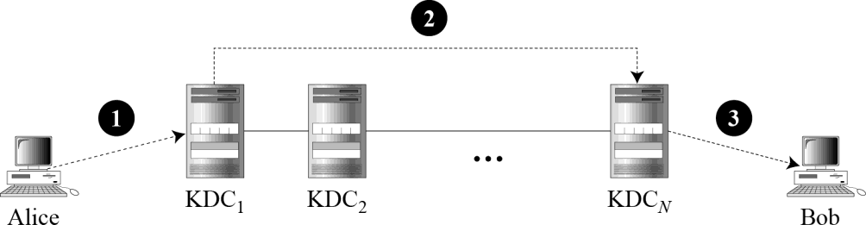Figure 15.2 shows KDCs all at the same level. We call this flat multiple KDCs.

Figure 15.2 Flat multiple KDCs

#### Hierarchical Multiple KDCs

* The concepts of flat multiple KDCs can be extended to a hierarchical system of KDCs, with one or more KDCs at the top of the hierarchy.
* For example, there can be local KDCs, national KDCs, and international KDCs.
* When Alice needs to communicate with Bob, who lives in another country , she sends her request to a local KDC; the local KDC, relays the request to the national KDC, the national KDC relays the request to an international KDC, the request is then relayed all the way down to the local KDC where Bob lives.
* 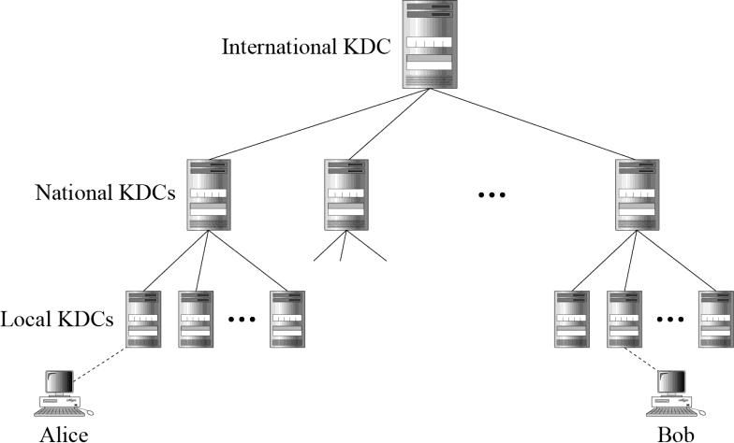Figure 15.3 shows a configuration of hierarchical multiple KDCs.

Figure 15.3 Hierarchical multiple KDCs

#### Session keys:

* A KDC creates a secret key for each member. The secret key can be used only between the member and the KDC, not between two members.
* If Alice needs to communicate secretly with Bob, she needs a secret key between herself and Bob.
* A KDC can create a session key between Alice and Bob, using their keys with the center.
* The keys of Alice and Bob are used to authenticate Alice and Bob to the center and to each other before the session key is established.
* After communication is terminated, the session key is no longer useful.

**A simple protocol using a KDC**

### Let us see how a KDC can create a session key KAB between Alice and Bob. Figure 15.4 shows the steps.

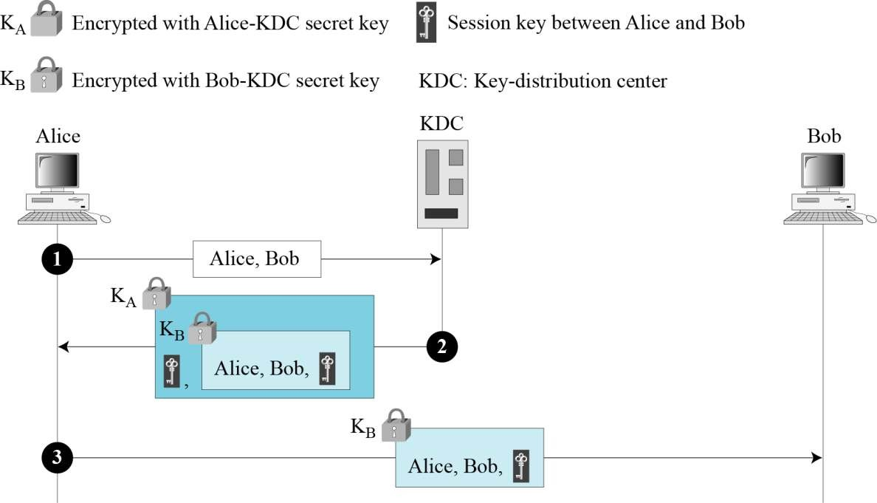

Figure 15.4 First approach using KDC

1. Alice sends a plaintext message to the KDC to obtain a symmetric session key between Bob and herself. The message contains her registered identity and the identity of Bob. This message is not encrypted, it is public. The KDC does not care.
2. The KDC receives the message and creates what is called ticket. The ticket is encrypted using Bob’s key (KB). The ticket contains the identities of Alice and Bob and the session key (KAB). The ticket with a copy of the session key is sent to Alice. Alice receives the message, decrypts it, and extracts the session key.
3. Alice sends the ticket to Bob. Bob opens the ticket and knows that Alice needs to send messages to him using KAB as the session key.

#### Needham – Schroeder Protocol

* + It is foundation for many other protocols.
  + This protocol uses multiple challenge-response interactions between parties to achieve a flawless protocol. It uses two nonce: RA and RB. Figure 15.5 shows the fine steps used in this protocol.

1. Alice sends a message to the KDC that includes her nonce, RA, her identity and Bob’s identity.
2. The KDC sends an encrypted message to Alice that includes Alice’s nonce, Bob’s identity, the

session key, and an encrypted ticket for Bob. The whole message is encrypted with Alice’s key.

1. Alice sends Bob’s ticket to him.
2. Bob sends his challenge to Alice (RB), encrypted with the session key.
3. 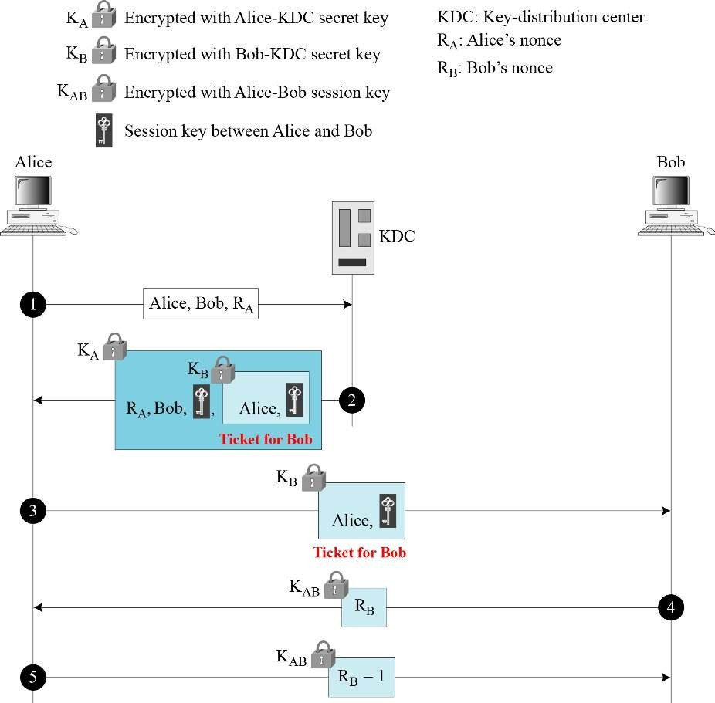Alice responds to Bob’s challenge. Note that the response carries RB-1 instead of RB.

Figure 15.5 Needham-Schroeder protocol

#### Otway –Rees Protocol

A third approach is the Otway-Rees protocol, another elegant protocol. Figure 15.6 shows this five-step protocol.

1. Alice sends a message to Bob that includes a common nonce, R , the identities of Alice and Bob, and a ticket for KDC that includes Alice’s nonce RA, a copy of the common nonce R, and the identities of Alice and Bob.
2. Bob creates the same type of ticket, but with his own nonce RB. Both tickets are sent to the KDC.
3. The KDC creates a message that contains R, the common nonce, a ticket for Alice and a ticket for Bob; the message is sent to Bob. The tickets contain the corresponding nonce, RA or RB, and the session key, KAB.
4. Bob sends Alice her ticket.
5. 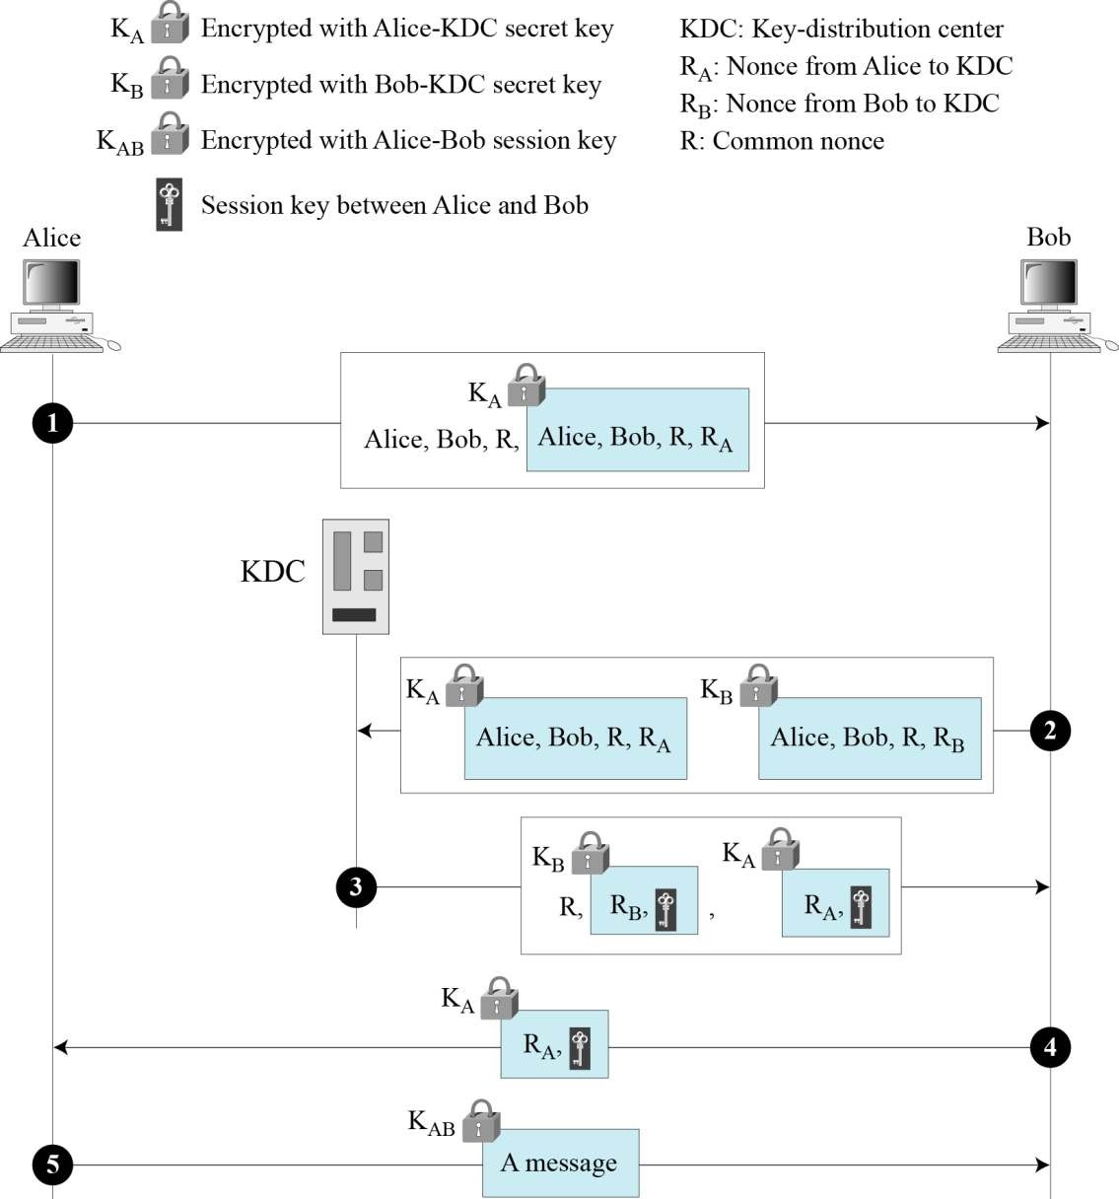Alice sends a short message encrypted with her session key KAB to show that she has the session key.

Figure 15.6 Otway-Rees protocol

# KERBEROS

* + Kerberos is an authentication protocol, and at the same time a KDC, that has become very popular.
  + Several systems, including Windows 2000, use Kerberos.
  + It is named after the three-headed dog in Greek mythology that guards the gates of Hades.

### Servers

* + - Three servers are involved in the Kerberos protocol: an authentication server (AS), ticket- granting server (TGS), and a real (data) server that provides services to others.
    - In our examples and figures, Bob is the real server and Alice is the user requesting service.
    - Figure 15.7 shows the relationship between these three servers.



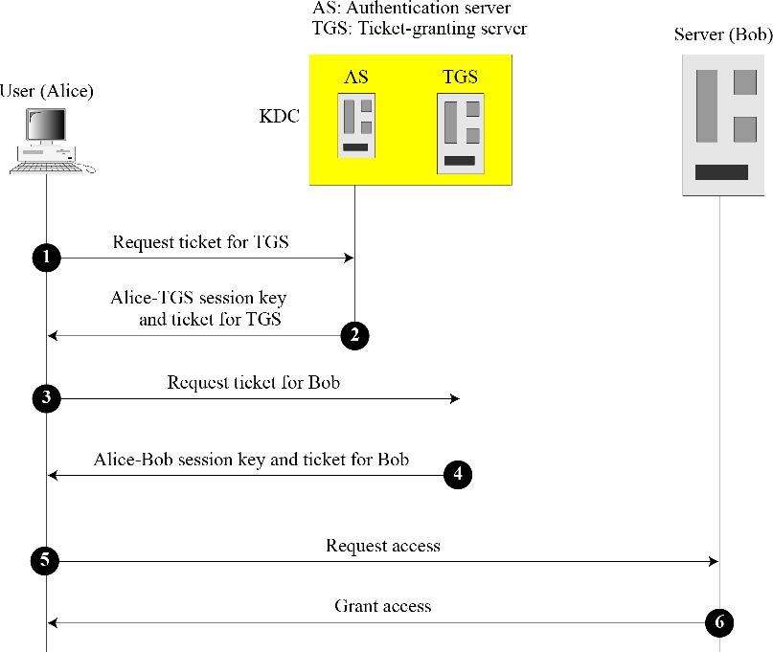

Figure 15.7 Kerberos servers

#### Authentication Server:

* + - * The authentication server (AS) is the KDC in the Kerberos protocol. Each user registers with the AS and is granted a user identity and a password.
      * The AS has a database with these identities and the corresponding passwords.
      * The AS verifies the user, issues a session key to be used between Alice and the TGS, and sends a ticket for the TGS.

#### Ticket-Granting Server:

* + - * TS issues a ticket for the real server (Bob).
      * It also provides the session key (KAB) between Alice and Bob.
      * Kerberos has separated user verification from the issuing of tickets.
      * In this way, though Alice verifies her ID just once with the AS, she can contact the TGS multiple times to obtain tickets for different real servers.

#### Real server

* + - * The real server (Bob) provides services for the user (Alice).
      * Kerberos is designed for a client –server program, such as FTP, in which a user uses the client process to access the server process.
      * Kerberos is not used for person-to –person authentication.

#### Operation

A client process can access a process running on the real server (Bob) in six steps, as shown in figure 15.8.

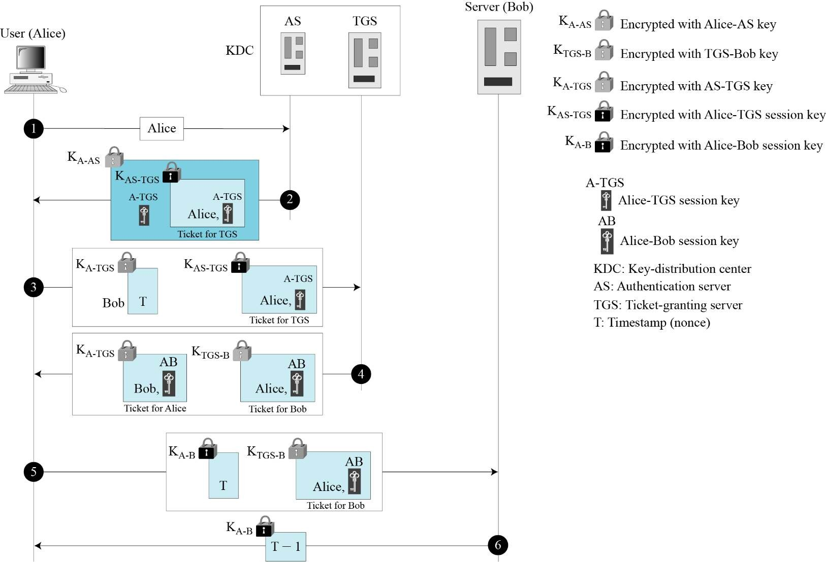

**Figure l5.8 *Kerberos example***

1. Alice sends her request to the AS in plaintext using her register identity.
2. The AS sends a message encrypted with Alice’s permanent symmetric key, KA-AS. The message contains two items: a session key, KA-TGS that is used by Alice to contact the TGS, and a ticket for the TGS that is encrypted with the TGS symmetric key, KA-TGS.
3. Alice now sends three items to the TGS. The first is the ticket received from the AS. The second is the name of the real server (Bob), the third is a timestamp that is encrypted by KA-TGS and the ticket are extracted.
4. Now, the TGS sends two tickets, each containing the session key between Alice and Bob

KA-B. The ticket for Alice is encrypted with KA-TGS; the ticket for Bob is encrypted with Bob’s

key, KTGS-B.

1. Alice sends Bob’s ticket with the timestamp encrypted by KA-B.
2. Bob confirms the receipt by adding 1 to the timestamp. The message is encrypted with KA-B and sent to Alice.

#### Using Different Servers

* + Note that if Alice needs to receive services from different servers, she need repeat only the

last four steps. The first two steps have verified Alice’s identity and need not be repeated.

#### Kerberos Version 5:

The minor differences between version 4 and version 5 are briefly listed below:

1. Version 5 has a longer ticket lifetime.
2. Version 5 allows tickets to be renewed.
3. Version 5 can accept any symmetric-key algorithm.
4. Version 5 uses a different protocol for describing data types.
5. Version 5 has more overhead than version 4

# 3. Symmetric Key Agreement

### Alice and Bob can create a session key between themselves without using KDC. This method of session-key creation is referred to as the symmetric – key agreement.

Here we have two common methods, Diffie Hellman and station – to-station are discussed here.

**Diffie and Hellman key-exchange Algorithm**

### This algorithm only used for key exchange

1. Select a prim number q.

### Find primitive roots of q.

1. Select a primitive root Ω among them.

### Select A’s private key XA < q.

1. Calculate A’s public key YA = ΩXA mod q.

### Select B’s private key XB < q.

1. Calculate B’s public key YB = ΩXB mod q.

### A’s shared key k = (YB)XA mod q.

1. B’s shared key k = (YA)XB mod q.

### Here A’s shared key equals to B’s shared key.

Proof:

### A’s shared key K = (YB)XA mod q.

= (ΩXB mod q)XA mod q

### = (ΩXBXA mod q) mod q

= (ΩXA mod q)XB mod q

### = (YA)XB mod q

= B’s shared key.

### In the above, p, is a large prime number on the order of 300 decimal digits (1024 bits).

Ω, is a generator of order q-1 in the group <Zq*, x>.

## Man-in-the-Attack

### The algorithm depicted above is insecure against a man-in-the-middle attack. Suppose Alice and Bob wish to exchange keys, and Darth is the adversary. The attack proceeds as follows (Figure 15.9).

* 1. Darth prepares for the attack by generating two random private keys XD1 and XD2 and then computing the corresponding public keys YD1 and YD2.

### Alice transmits YA to Bob.

* 1. Darth intercepts YA and transmits YD1 to Bob. Darth also calculates K2 = (YA) XD2 mod q.

### Bob receives YD1 and calculates K1 = (YD1) XB mod q.

* 1. Bob transmits YB to Alice.

### Darth intercepts YB and transmits YD2 to Alice. Darth calculates K1 = (YB) XD1 mod q.

* 1. Alice receives YD2 and calculates K2 = (YD2) XA mod q.

### At this point, Bob and Alice think that they share a secret key, but instead Bob and Darth share secret key K1 and Alice and Darth share secret key K2. All future communication between Bob and Alice is compromised in the following way.

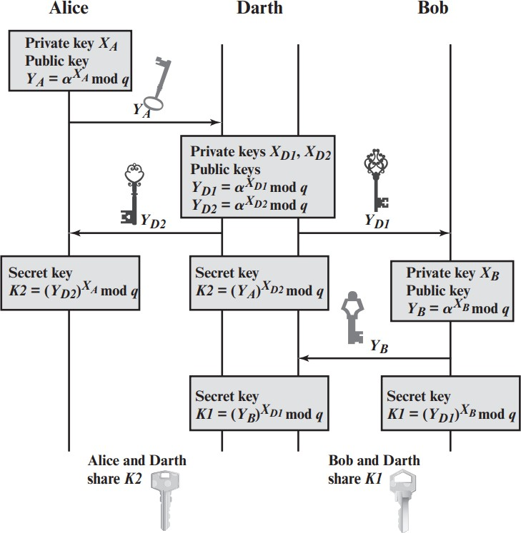

Figure 15.9: Man-in-the-Middle Attack

## Example l:

### Q = 353

Ω = 3

### XA = 97 < 353

YA = ΩXA mod q

### = 397 mod 353

= 40.

### XB = 233 < 353

YB = ΩXB mod q

### =3233 mod 353

= 248.

### A’s shared key = (YB)XA mod q

= (248)97 mod 353

### = 160.

B’s shared key = (YA)XB mod q

### = (40)233 mod 353

= 160.

## Example 2:

### User A and B use the Diffie-Hellman key exchange technique with a common prime q = 71 and a primitive root

Ω = 7.

### If user A has private key XA = 5, what is A’s public key YA?

* + 1. If user B has private key XB = 12, what is B’s public key YB?

### What is the shared secret key?

1. A’s public key

### YA = ΩXA mod q

= 75 mod 71

### = 16807 mod 71

= 51

### B’s public key YB

YB = ΩXB mod q

### = 712 mod 71

= 4

### Shared secret key

K = (YB)XA mod q

### = 45 mod 71

= 1024 mod 71

### = 30.

**c)** Shared secret key

### K = (YA)XB mod q

= 5112 mod 71

= 30.

## Example 3:

### Consider a Diffie-Hellman Scheme with a common prime q = 11 and a primitive root Ω = 2.

1. Show that 2 is a primitive root of 11.

### If user A has public key YA= 9, what is A’s private key XA?

1. If user B has public key YB = 3, what is the shared secret key K?

## a)

|  |  |  |  |  |  |  |  |  |  |  |
| --- | --- | --- | --- | --- | --- | --- | --- | --- | --- | --- |
|  | a1 | a2 | a3 | a4 | a5 | a6 | a7 | a8 | a9 | a10 |
| ai | 2 | 4 | 8 | 16 | 32 | 64 | 128 | 256 | 512 | 1024 |
| ai mod 11  1  i  10 | 2 | 4 | 8 | 5 | 10 | 9 | 7 | 3 | 6 | 1 |

ai mod 11 where 1  i  10 have ten different elements from 1 to 10. So, 2 is a primitive root of 11.

## b)

### YA = ΩXA mod q 9 = 2XA mod 11

9 = 26 mod 11

### 9 = 64 mod 11

🢥 XA = 6

## c)

### Shared secret key K = (YB) XA mod q

= 36 mod 11

### = 729 mod 11

= 3

## Example 4:

### Alice and Bob use the Diffie–Hellman key exchange technique with a common prime q = 157 and a primitive root a = 5.

1. If Alice has a private key XA = 15, find her public key YA.

### If Bob has a private key XB = 27, find his public key YB.

1. What is the shared secret key between Alice and Bob?

### A’s public key

YA = ΩXA mod q

### = 515 mod 71

= 16807 mod 157

### = 79

* 1. B’s public key YB

### YB = ΩXB mod q

= 527 mod 157

### = 65

* 1. Shared secret key

### K = (YB)XA mod q

= 6515 mod 157

### = 78

**c)** Shared secret key

K = (YA)XB mod q

## Example 5:

### = 7927 mod 157

= 78

### Alice and Bob use the Diffie-Hellman key exchange technique with a common prime q = 23 and a primitive root a = 5.

1. If Bob has a public key YB = 10, what is Bob’s private key YB?

### If Alice has a public key YA = 8, what is the shared key K with Bob?

1. Show that 5 is a primitive root of 23.

## a)

### YA = ΩXA mod q 10 = 5XB mod 23

10 = 53 mod 23

🢥 XB = 3

## b)

### Shared secret key K = (YB) XA mod q

= 83 mod 23

= 6

## c)

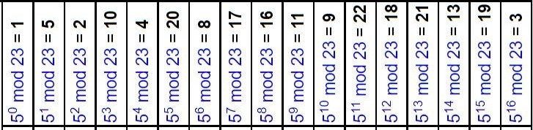

### From the above table we can say 5 is a primitive root of 23.

* 1. Station–to–Station key Agreement

The station-to–station protocol is a method based on Diffie-Hellman. It uses digital signatures with public key certificates to establish a session key between Alice and Bob as shown in figure 15.12.

The following shows the steps:

* + - After calculating R1, Alice sends R1 to Bob (steps 1 and 2 in Fig 15.12).
    - After calculating R2 and the session key, Bob concatenates Alice’s ID, R1 and he signs the result with his private key (steps 3, 4 and 5 in Fig 15.12).
    - After calculating the session key, if Bob’s signature is verified, Alice concatenate Bob’s ID,R1 and R2.she then signs the result with her own private key and sends Bob. The signature is encrypted with the session key (steps 6, 7 and 8 in Fig 15.12).
    - If Alice’s signature is verified, Bob keeps the session key (steps 9 in Fig 15.12).

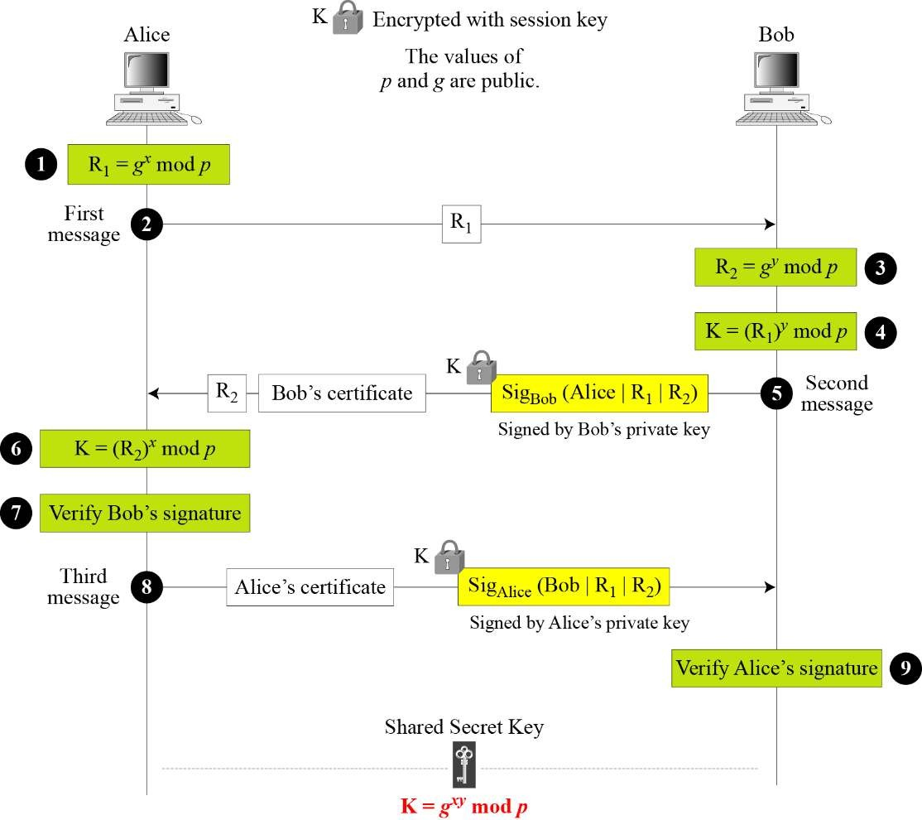

Figure 15.12 Station-to-station key agreement method

# Public- Key Distribution

* + In Asymmetric key cryptography, people do not need to know a symmetric shared key.
  + If Alice wants to send a message to Bob, she only needs to know Bob’s public key, which is

open to the public and available to everyone.

* + If Bob needs to send a message to Alice, he only needs to know Alice’s public key, which is

also known to everyone.

* + In public key cryptography, everyone shields a private key and advertises a public key.

### Public Announcement

The native approach to announce public keys publicly. Bob can put his public key on his website or announce it in a local or national newspaper.

* + - When Alice needs confidential message to Bob, she can obtain Bob’s public key from his site or from the newspaper, or even send a message to ask for it.
    - This approach, however, is not secure, it is subject to forgery.
    - For example, Eve could make such a public announcement.
    - Before Bob can react, damage could be done. Eve can fool Alice into sending her a message that is intended for Bob.
    - Eve could also sign a document with a corresponding forged private key and make everyone

believe it was signed by Bob.

* + - Eve can intercept Bob’s response and substitute her own forged public key for Bob’s public

key.

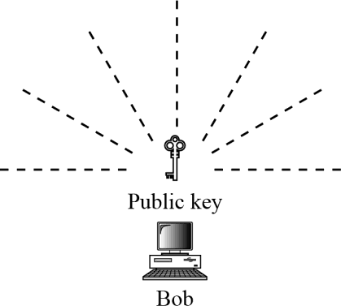

Figure 15.13 Announcing a public key

### Trusted Center

* + - A more secure approach is to have a trusted center retain a directory of public keys.
    - The, directory, like the one used in a telephone system, is dynamically updated. Each user can select a private and public key, keep the private key, and deliver the public key for insertion into the directory.
    - The center requires that each user register in the center and prove his or her identity.
    - The directory can be publicly advertised by the trusted center.
    - The center can also respond to any inquiry about a public key.

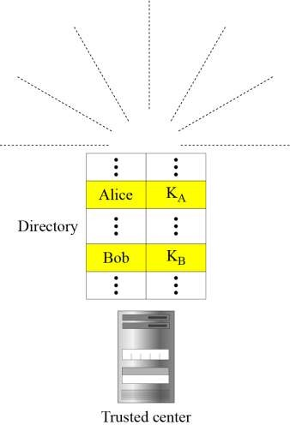

Figure 15.14 Trusted center

### Controlled Trusted Center:

* + - A higher level of security can be achieved if there are added controls on the distribution of the public key.
    - The public key announcements can include a timestamp and be signed by an authority to prevent interception and modification of the response.
    - If Alice, needs to know Bob’s public key, she can send a request to the center including Bob’s

name and timestamp.

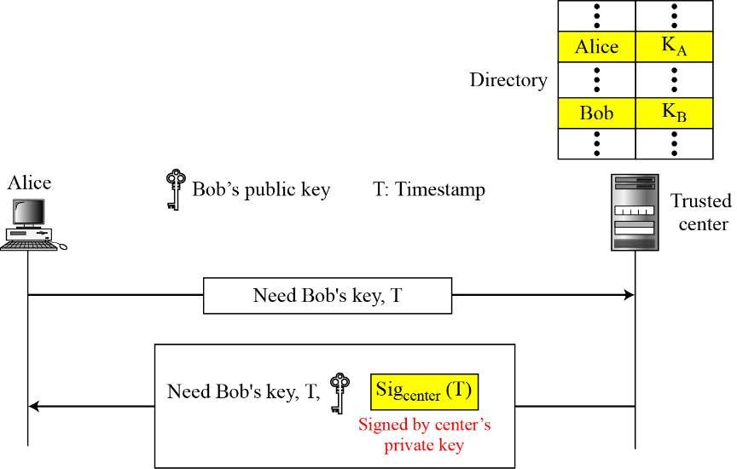

Figure 15.15 Controlled trusted center

### Certification Authority

* + - The previous approach can create a heavy load on the center if the number of requests is large.
    - The alternative is to create public-key certificates.
    - Bob wants two things; he wants people to know his public key, and he wants no one to accept a forged public key as his.
    - Bob can go to a certification authority (CA), a federal or state organization that binds a public key to an entity and issues a certificate.
    - The CA check Bob’s identification. If then asks for Bob’s public key and a writes it on the certificate.
    - To prevent the certificate itself from being forged, the CA signs the certificate with its private key.
    - Now Bob can upload the signed certificate, anyone who wants Bob’s public key downloads the signed certificate and uses the center’s public key to extract Bob’s public key. Figure

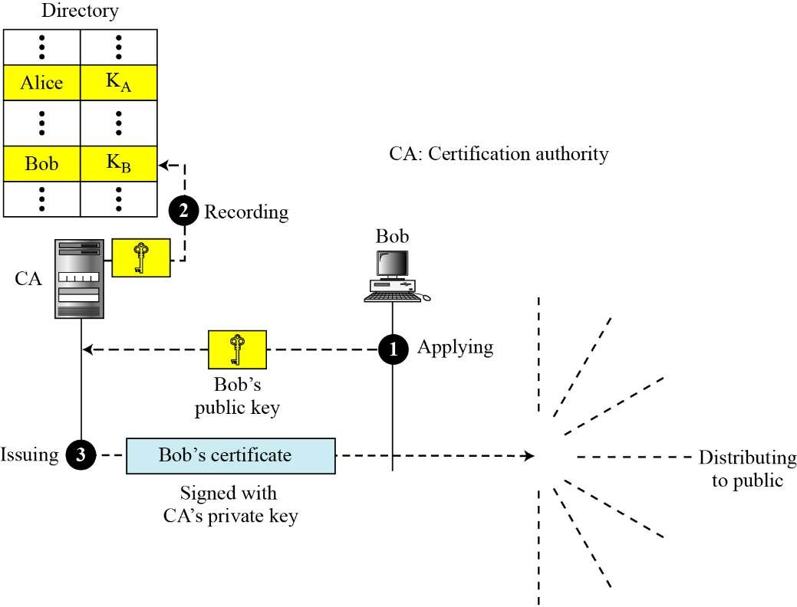15.16 shows the concept.

Figure 15.16 Certification authority

### 4.5 X.509

* Although the use of a CA has solved the problem of public key fraud, it has created a side- effect. Each certificate may have a different format.
* If, Alice wants to use a program to automatically download different certificates and digests belonging to different people, the program may not be able to do this.
* One certificate may have the public key in one format and another in a different format.
* The public key may be on the first line in one certificate, and on the third line in another, anything that needs to be used universally must have a universal format.
* The ITU has designed X.509.

#### Certificate

Figure 15.17 shows the format of a certificate.

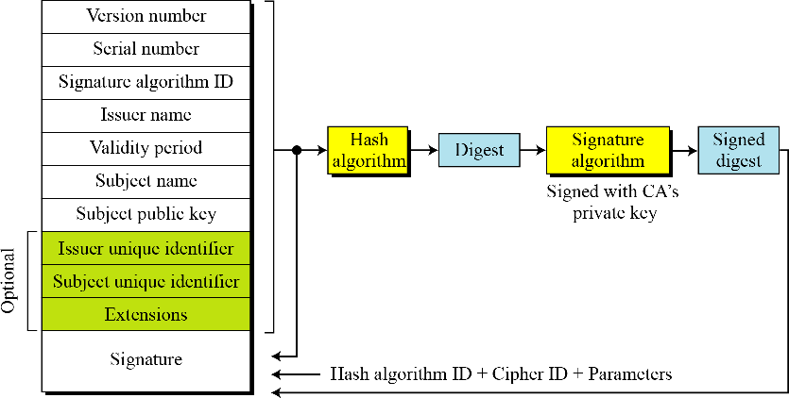

Figure 15.17 X.509 certificate format A certificate has the following fields:

* **Version number:** This field defines the version of X.509 of the certificate. The version number started at 0; the current version is 2.
* **Serial number:** This field defines a number assigned to each certificate. The value is unique for each certificate issuer.
* **Signature algorithm ID:** This field identifies the algorithm used to sign the certificate. Any parameter that is needed for the signature is also defined in this field.
* **Issuer name:** This field identifies the certification authority that issued the certificate. The name is normally a hierarchy of strings that defines a country, a state, organization, department, and so on.
* **Validity Period:** This field defines the earliest time and the latest time the certificate is valid.
* **Subject name:** This field defines the entity to which the public key belongs. It is also a hierarchy of strings. Part of the field defines what is called the common name, which is the actual name of the beholder of the key.
* **Subject public key:** This field defines the Owner’s public key, the heart of the certificate.

This field also defines the corresponding public-key algorithm and its parameters.

* **Issuer unique identifier:** This optional field allows two issuers to have the same issuer field value, if the issuer unique identifiers are different.
* **Subject unique identifier:** This optional field allows two different subjects to have the same subject field value, if the subject unique identifiers are different.
* **Extensions:** This optional field allows issuers to add more private information to the certificate.
* **Signature:** This field is made of three sections. The first section contains all other fields in the certificate. The second section contains the digest of the first section encrypted with the CA’s public key. The third section contains the algorithm identifier used to create the second section.

#### Certificate Renewal

* Each certificate has a period of validity. If there is no problem with the certificate, the CA issues a new certificate before the old one expires.
* The process is like the renewal of credit cards by a credit card company; the credit card holder normally receives a renewed credit card before the one expires.

#### Certificate Revocation

**In some cases a certificate must be revoked before its expiration. Here are some examples:**

1. The user’s private key might have been comprised.
2. The CA is no longer willing to certify the user. For example, the user’s certificate relates to

an organization that she no longer works for.

1. The CA’s private key, which can verify certificates, may have been compromised. In this case, the CA needs to revoke all unexpired certificates.

The revocation is done by periodically issuing a certificate revocation list (CRL). Figure 15.18 shows the certificate revocation list.



Figure 15.17 Certificate revocation format

A certificate revocation list has the following fields:

* **Signature algorithm ID:** This field is the same as the one in the certificate.
* **Issuer name:** this field is the same as the one in the certificate.
* **This update date:** This field defines when the list is released.
* **Next update date:** This field defines the next date when the new list will be released.
* **Revoked certificate:** This is a repeated list of all unexpired certificates that have been revoked. Each list contains two sections: user certificate serial number and revocation date.
* **Signature:** This field is the same as the one in the certificate list.

#### Delta Revocation

* To make revocation more efficient, the delta certificate revocation list, has been introduced.
* A delta CRL, is created and posted on the directory if there are changes after this update date and next update date.

### Public-Key Infrastructures (PKI)

* + - It is a model for creating, distributing, and revoking certificates based on the X.509.
    - The internet Engineering Task Force has created the Public-Key Infrastructure X.509 (PKIX).

#### Duties

Several duties have been defined for a PKI. The most important ones are shown in figure 15.19.

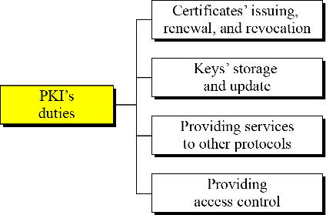

Figure 15.19 Some duties of a PKI

#### Trust Model

It is not possible to have just one CA issuing all certificates for all users in the world.

There should be many CAs, each responsible for creating, sorting, issuing and revoking a limited number of certificates. The trust model defines rules that specify how a user can verify a certificate received from a CA.

#### Hierarchical Model

* + - In this model there is a tree type structure with a root CA. The root CA has a self- signed, self-issued certificate; it need to be trusted by other CAs and users for the system to work.
    - Figure 15.20 shows a trust model of this kink with three hierarchical levels. The number of levels can be more than three in a real situation.

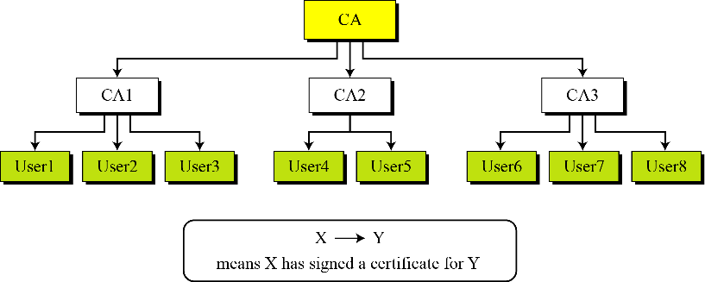

Figure 15.20 PKI hierarchical model

The figure shows that the CA (the root) has signed certificates for CA1, CA2, and CA3; CA1 has signed certificates for User1, User2, and User3; and so on. PKI uses the following notation to mean the certificate issued by authority X for entity Y.

X<<Y>>

#### Mesh model

* + - The hierarchical model may work for an organization or a small community.
    - A larger community may need several hierarchical structures connected together. One method is to use a mesh model to connect the roots together.
    - 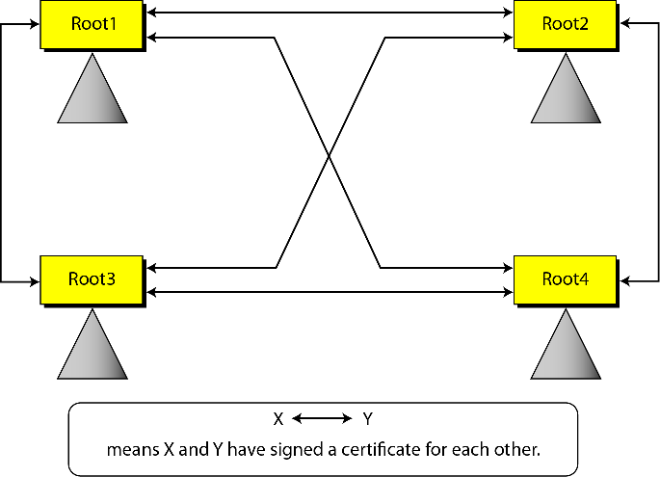In this model, each root is connected to every other root as shown in figure 15.21.

Figure 15.21 Mesh model

### = = = = = = = = = = = = = = = = = = = = = = = = = = = = = = = = = = = = = = = = = = = = = = = = = = = =